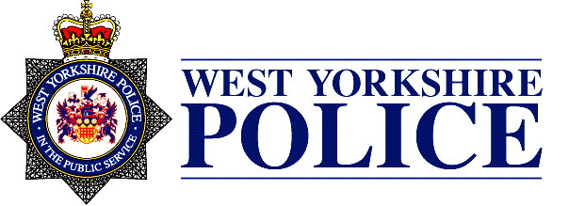
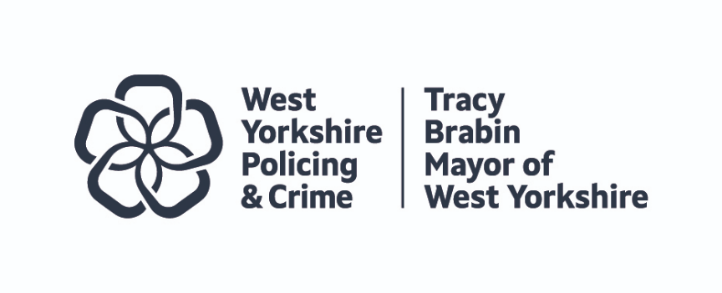

JOINT INDEPENDENT AUDIT COMMITTEE ANNUAL REPORT 2023-24

Terms of Reference Point | Policing and Crime Team Coverage | West Yorkshire Police Coverage
Governance, Risk and Control
- Review the corporate governance arrangements against the good governance framework, including the ethical framework and consider the local code of governance. | Members received regular business updates from the Policing and Crime Team.  Members received regular updates on the revised scheme of delegation regarding sponsorship on the treasurer function. (Scheme of delegation October 2023). The scheme of consent was reported February 2023.  Members have considered reports on business interests, gifts and hospitality and information governance in the Policing and Crime Team (June 2023) and received a report on the Commissioning and Grants strategy (February 2024).  The Chair of the Audit Committee attended the Mayor’s Partnership Executive Group (PEG) on 27 January 2023, 28 April 2023 and 5 September 2023 and has observed risk management in the Mayor’s Policing and Crime Team by attending meetings where risk management has been reported, including the Executive Team meeting on 8 November 2023. The chair will also attend the Governance and Audit Committee on 7 March 2024. | Members received regular business updates from West Yorkshire Police (WYP).  Members received regular updates on the Programme of Change, on and the revised scheme of delegation regarding sponsorship on the treasurer function.  Members have considered reports on business interests, gifts and hospitality and information governance (June 2023).  The Chair of the Audit Committee attended and the Police Risk Management meetings on 8 August 2022, 7 November 2022, 6 February 2023, 6 September 2023 and 1 November 2023.
- Review the annual governance statements prior to approval and consider whether they properly reflect the governance, risk and control environment and supporting assurances and identify any actions required for improvement. | Members reviewed the annual governance statements for the Policing and Crime Team reflecting the financial year 2022-23 (October 2023). | Members reviewed the annual governance statements for WYP reflecting the financial year 2022-23 (October 2023).
- Review treasury management policies, practices and activities including an annual strategy and plan | Members have reviewed the treasury management strategy (June 2023).
- Consider the arrangements to secure value for money and review assurances and assessments on the effectiveness of these arrangements. |  | Members received External Auditor’s commentary on WYP’s VFM arrangements (February 2024).  Members receive reports on tender exceptions at each meeting.
- Consider the framework of assurance and ensure that it adequately addresses the risks and priorities of the Mayor’s PCC functions/the Force. | Members reviewed the joint Assurance Framework (September 2023). | Members reviewed the joint Assurance Framework (September 2023).
- Monitor the effective development and operation of risk management, review the risk profile, and monitor progress of the Mayor’s PCC functions/the Chief Constable in addressing risk-related issues reported to them. | Members receive a detailed risk management reports the Mayor’s PCC functions at each meeting.  The Chair observed risk management in the Mayor’s Policing and Crime Team by attending meetings where risk management has been reported, including the Executive Team meeting on 8 November 2023 | Members receive a detailed risk management reports for WYP at each meeting.  The Chair attends the WYP Risk Management Group.
- Consider reports on the effectiveness of internal controls and monitor the implementation of agreed actions. | None reported. | Members received regular internal audit reports including draft reports in advance of management responses and progress in implementing recommendations from Internal Audit reports.
- Review arrangements for the assessment of fraud risks and potential harm from fraud and corruption and monitor the effectiveness of the counter fraud strategy, actions and resources. | This receives oversight by the WYCA Governance and Audit Committee. | Members received a report on the Counter-fraud and Counter-corruption Strategy (February 2024).
- To review the governance and assurance arrangements for significant partnerships or collaborations. | Members received a commissioning update (February 2024) and received a report on sponsorship (June 2023).  Members receive regular updates on the National Police Air Service (NPAS). | Members received a report on sponsorship (June 2023).  Members receive regular updates on the National Police Air Service (NPAS).
- To receive requests from, and provide advice to, the Director, Finance and Commercial Services, WYP Assistant Chief Officer, Monitoring Officer and Head of Internal Audit. | None required. Regular dialogue maintained. | None required. Regular dialogue maintained.
Internal Audit
11. Annually review the internal audit charter and resources. | The WYCA Internal Audit Team report to the WYCA Governance and Audit Committee.  The work of the WYCA Internal Audit team provides indirect assurance over the work of the Police & Crime Team through its work on the WYCA control environment.  In addition, specific audits are occasionally carried out on Police & Crime team activity. These will be reported to JIAC but none have been received in this year. | Members will reviewed the Internal Audit Charter, Internal Audit Strategy and work plan (February 2024).
12. Review the internal audit plan and any proposed revisions to the internal audit plan. |  | Members have reviewed Internal Audit coverage.
13. Oversee the appointment process and consider the adequacy of the performance of the internal audit service and its independence |  | Members regularly scrutinise internal audit performance against the internal audit work plan.
14. Consider the Head of Internal Audit’s annual report and opinion, and a regular summary of the progress of internal audit activity against the audit plan, and the level of assurance it can give over corporate governance arrangements. |  | Members received the 2022/23 Internal Audit annual report (October 2023).  Members receive reports of all limited assurance reports.
15. To consider the Head of Internal Audit’s statement of the level of conformance with the PSIAS and LGAN and the results of the QAIP that support the statement – these will indicate the reliability of the conclusions of internal audit. |  | The Internal Audit function is subject to external quality assessment every five years in line with PSIAS recommendations.
16. Consider summaries of internal audit reports and such detailed reports as the committee may request from the Mayor/the Chief Constable, including issues raised or recommendations made by the internal audit service, management response and progress with agreed actions. |  | Members regularly receive internal audit reports.
17. Consider a report on the effectiveness of internal audit to support the Annual Governance Statements (AGS), where required to do so by the Accounts and Audit Regulations (England) 2015. | The review of WYCA Internal Audit is planned to go to the WYCA Governance and Audit Committee (August 2024). | The WYP Internal Audit Team carry out an annual self-assessment of effectiveness against Public Sector Internal Audit Standards and every five years are subject to an external peer led review. The results of these exercises are reviewed by JIAC.
18. To consider any impairments to independence or objectivity arising from additional roles or responsibilities outside of internal auditing of the Head of Internal Audit. To make recommendations on safeguards to limit such impairments and periodically review their operation. | None noted in the reporting period. | None noted in the reporting period.
External Audit
19. Support the independence of external audit through consideration of the external auditor’s annual assessment of its independence and review of any issues raised by either PSAA or the auditor panel as appropriate. | The WYCA External Audit Team report to the WYCA Governance and Audit Committee. | Members have considered the External Auditor’s report at each meeting.
20. Comment on the scope and depth of external audit work, its independence and whether it gives satisfactory value for money. |  | Members receive external audit reports at each meeting. Members comment on the scope and depth of external audit work, its independence and whether it provides value for money. The external audit 2022/23 annual report (February 2024).
21. Consider the external auditor’s annual management letter, relevant reports and the report to those charged with governance. |  | Members received a progress report (December 2023).
22. Consider specific reports as agreed with the external auditor. |  | As above, members consider reports from External Audit at each meeting of the Committee.
23. Advise and recommend on the effectiveness of relationships between external and internal audit and other inspection agencies or relevant bodies. |  | No issues noted in the reporting period.
Financial Reporting
24. Review the annual statement of accounts. Specifically, to consider whether appropriate accounting policies have been followed and whether there are concerns arising from the financial statements or from the audit of the financial statements that need to be brought to the attention of the Mayor and/or the Chief Constable. | The Mayor’s PCC function, hosted by WYCA are included in the CA annual statement of accounts - there are delays on the publication of their accounts. | Members will benefit from a familiarisation session on the draft statements of accounts (Spring 2024) and considered the WYP draft annual accounts for 2022-23 (October 2023).  Members receive regular budget management reports and business updates at each meeting.
25. Consider the external auditor’s report to those charged with governance on issues arising from the audit of the financial statements. | The WYCA Governance and Audit Committee consider this. | As above, members receive regular reports from External Audit including the annual management letter.
Accountability Arrangements
26. On a timely basis report to the Mayor and the Chief Constable with its advice and recommendations in relation to any matters that it considers relevant to governance, risk management and financial management. | The Mayor is represented at each meeting by WYCA statutory officers who have a responsibility to report relevant matters. | The Chief Constable is represented at each meeting by their statutory officers who have a responsibility to report relevant matters.
27. Report to the Mayor and the Chief Constable on its findings, conclusions and recommendations concerning the adequacy and effectiveness of their governance, risk management and internal control frameworks, financial reporting arrangements, and internal and external audit functions. | The work programme and terms of reference are designed to be able to provide such assurance. Where concerns have been raised by the Audit Committee these have been addressed.  The Chair of the committee met with the Deputy Mayor for Policing and Crime on 8 August 2023 to provide an update on the work of the Committee and has attended the Police and Crime Panel on 6 October 2023 to provide an update on the work of the Committee and answer questions. | The work programme and terms of reference are designed to be able to provide such assurance. Where concerns have been raised by the Audit Committee these have been addressed.  The Chair of the Committee met with the Chief Constable on 18 October 2023 to provide an update on the work of the Committee.
28. Review its performance against its terms of reference and objectives on an annual basis and report the results of this review to the Mayor and the Chief Constable. | Members considered a self-assessment report (February 2024).  The Chair of the Committee met with the Deputy Mayor for Policing and Crime on 8 August 2023 to provide an update on the work of the Committee and has attended the Police and Crime Panel on 6 October 2023 to provide an update on the work of the Committee and answer questions. | Members considered a self-assessment report (February 2024).  The Chair of the Committee met with the Chief Constable on 18 October 2023 to provide an update on the work of the Committee.
29. Report to the Governance and Audit Committee of the Combined Authority on an annual basis on the work of the Committee and any matters relating to accounts and audit functions. | The Chair of the Committee will attend the Governance and Audit Committee in Spring 2024.
30. Publish an annual report on the work of the committee. | An annual report is given to members and made publicly available online. | An annual report is given to members and made publicly available online.

