PERFORMANCE MONITORING REPORT

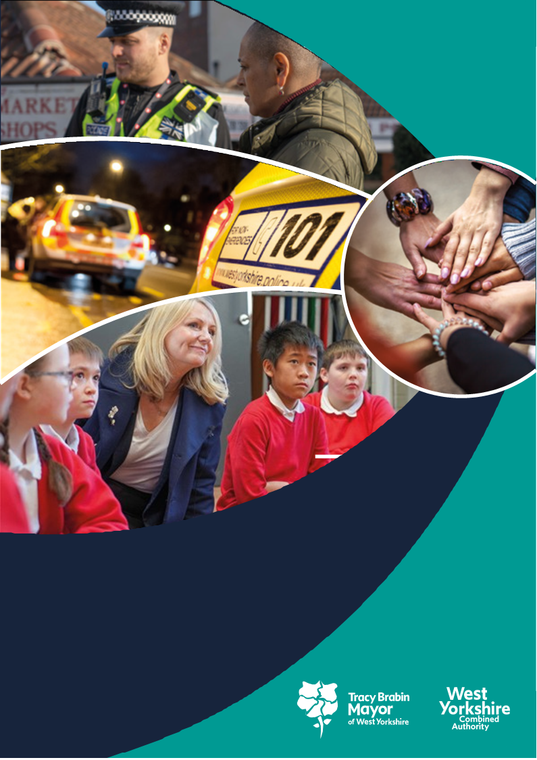

**West Yorkshire:**

**Safe. Just. Inclusive**

**Police and Crime Plan 2021-2024**

**1. Supporting Victims and Witnesses and Improving Criminal Justice Outcomes**



**1.1 Victim Satisfaction**

1.1.1 The latest victim satisfaction rate stands at 71.9% for the 12 months to March. The latest position is the same as 12 months ago.



1.1.2 Performance levels range from around 72% at Bradford, Leeds and Kirklees to 78% at Calderdale. The biggest increase has been seen at Wakefield, up almost 5% points. The district satisfaction score only looks at crimes dealt with by the district. Those telephone investigations dealt with via the Force Crime Management Unit (FCMU) are not included in the district ratings but are included in the overall West Yorkshire rating.

1.1.3 Safety and Welfare callers and Domestic Abuse victims are the most satisfied, with levels over 80%. The biggest reductions in overall satisfaction are for Theft and Arson and Criminal Damage. Robbery victims have reported the biggest increases in levels of overall satisfaction, up almost 7 percentage points.

1.1.4 Satisfaction for victims of Domestic Abuse is at 82.2%, is higher than the all crime satisfaction rate of 71.9% (as shown above) and victims of stalking gave a satisfaction rate of 75.8% which is also above the all crime rate.

## 1.2 Maintain high levels of calls answered on target.

1.2.1 In the latest 12 months to March 2024, the number of total contacts into West Yorkshire Police have fallen by 2.9% (46k fewer contacts). During the same period, 999s have increased by 2.0% (10k more calls), 101 calls have fallen by 7.0% (50k fewer calls), Other calls have increased by 6.2% (4k more calls) and online contacts have fallen by 3.7% (10k fewer contacts). The very latest quarter is reporting a larger downturn in demand with overall contacts falling by 19.8% and all contact types reporting a reduction in the last three months to January 2024.

1.2.2 The latest national 999 call handling figures report that the Force has the 2nd fastest average answer time in the country during the latest quarter (5.7 seconds), the Force answers just 0.4% of 999s at 60 seconds or longer (4th best nationally) whilst over 90% (92.3%) of 999 calls are answered in under 10 seconds (ranked 6th best nationally).

101 call handling is also showing good improvements. The average time to answer 101 calls in the three months to March 2024 is 3mins:24secs (down from 4mins:22secs in the same quarter last year) whilst the 101 abandonment rate has fallen significantly from 23% in Jan-Mar 2023 to 9% in Jan-Mar 2024.

1.2.3 The below graphs show the current 101 rates with a peak in June 2023, when the abandonment rate was also high. The second chart looks at the average answer time – the IVR is the Interactive Voice Response, which is the automatic update to listeners to make sure they are holding on for the right reason (i.e. could their call be dealt with easier online or should it be directed elsewhere). The call times are measured after this has taken place and any abandonment due to this taken out (i.e. AVR – abandonment after IVR).

1.2.4 For information – The above is from Police.uk who produce statistics on 999 answering times, but these also include transfer times from BT, which can be 4-6 seconds and can vary across police forces. The comparison data with other forces is available [here](https://www.police.uk/pu/your-area/west-yorkshire-police/performance/999-performance-data/?tc=BDT_BW).

## 1.3 Improve Outcomes

**1.3.1 Rape and Serious Sexual Offences**



1.3.2 The above table shows the position in March 2024 in comparison to the same time last year. The numbers of rape offences are 120 offences higher than the same time last year, and the outcome rate has increased by 1.0% which means that 47 more victims have received a positive outcome.

1.3.3 The most recent data that is available nationally is up to November 2023, so not a direct comparison with the above. This data compares forces by looking at crimes per 100,000 population. Previously other areas were not close in number to West Yorkshire, but now we see large increases in some areas due to implementing more stringent crime recording practices bringing them to similar numbers – whereas the effect of ~~CDI~~ this is getting slower in WYP.

**Serious Sexual Offences**



1.3.4 Serious Sexual Offence numbers have decreased by 1.4% in comparison with the same time last year, and the positive outcome rate has risen by 0.8% with 56 more victims receiving a positive outcome.



1.3.5 Nationally the Serious Sexual Offence category is not reported on, as this category includes the rape offences above, but there is a category of ‘Other Sexual Offences’ which does not include the Rape Offences. In a similar manner to the above Rape Offences (with the baseline Jan – Dec 2019), the table below gives an indication of the current position.

Most forces have seen an increase in these crime types and now have similar rates to WYP.

**1.3.6 Domestic Abuse Crime Outcomes**



1.3.7 The above looks at the data for the last 12 months compared to the previous 12 months. The number of Domestic Abuse Crimes has fallen by over 9,000 in the last 12 months which is a 14.3% decrease. The outcome rate has risen by 0.5% although the actual numbers of positive outcomes have fallen.

1.3.8 As requested the below data looks at domestic crimes per 1,000 population across West Yorkshire.



Bradford has the highest number per 1,000 population but is also seeing the biggest change, and Kirklees has the lowest per 1,000 population but is seeing the lowest change which indicates that the change in recording practices is proportionately affecting the areas with higher original crime figures.

**1.4 Increase proportion of crimes with victim initial needs assessment**

1.4.1 The Initial Victim Needs Assessment (IVNA) is part of the Victims Code of Practice and is intended to:

1. Determine if the victim needs support.

2. Establish the type of support needed.

3. Assess whether the victim is vulnerable or intimidated.

4. Consider whether the victim is entitled to enhanced rights.

1.4.2 The guidance from the College of Policing shows that obtaining this at initial contact is important to the ongoing investigation, as well as a key consideration towards effective communication and engagement with the victim. This has continued to rise over the life of the plan and is now at over 99%.

## 1.5 Criminal Justice Measures

1.5.1 It has been agreed that the LCJB will scrutinise a written report on the Delivery Data Dashboards at each Executive Board meeting going forward, providing the dataset has been delivered nationally. These delivery dashboards include the transforming summary justice target data, but also include a number of other data sets. The measures from the Delivery Dashboards give us the opportunity to compare current performance with national performance and this report will be able to give these comparisons against the agreed priorities.

1.5.2 The most recent data to the Local Criminal Justice Board gave the data up to the end of Q2 2023 (Sept 2023)

1. A link to the Delivery Data Dashboards is here - [Home - CJS Dashboard (justice.gov.uk)](https://criminal-justice-delivery-data-dashboards.justice.gov.uk/)
2. The following concentrates on exceptions rather than the whole data set.
3. The number of victim-based recorded offences has decreased, although the volumes referred have increased slightly.
4. WYorks has a high percentage of cases accepted by CPS at first triage (85.8% compared with a national average of 64.0% in the last qtr.).
5. The average days from police referring a case to the CPS and the CPS authorising a charge has increased and is now above the national average (56.0 vs 43.1)
6. Early guilty plea rates at Magistrates is slightly lower than the national rate, but the actual guilty plea rate and the conviction after trial at Magistrates is similar to the national rate.
7. Early guilty plea rates at Crown Court are higher than the national rate, but the actual guilty plea rate and the conviction after trial at Crown Court is significantly higher than the national rate.
8. Non-conviction due to victim issues is slightly higher than average for Magistrates court, but significantly higher for Crown Court.
9. There are currently over 3,800 cases outstanding both at Magistrates court and at Crown Court. 619 cases have been outstanding for a year or more at Crown Court and there are over 7,000 defendants with a case outstanding in either/both courts.

**1.5.4 Decrease ineffective trial rate (Magistrates Court)**

1.5.5 The figures shown on the original table for this section are for 2022/23 and then for up to November 2023, This shows an increase (5.9%) and is reflective of the increases in the number of trials taken forward.

**1.5.6 Increase volume of early guilty pleas**

1.5.7 The increase of the number of early guilty pleas negates the need for a trial and frees up time which could be used elsewhere.

1.5.8 Again these figures compare the same timescales as the above and this shows an increase in both the Magistrates and Crown Courts.

**1.5.9 Decrease average time taken for cases to be brought to resolution.**

1.5.10 “Average Days from First Listing to Completion” has changed definition in the new TSJ National Results. The new measure is still Average Days from First Listing to Completion, but completion now refers only to ‘Not Guilty or No Plea”. This means that results from Q3 2023 onwards are not comparable with previous quarters.

**2 KEEPING PEOPLE SAFE AND BUILDING RESILIENCE**

# 

**2.1 Monitor the number of young persons flagged as at risk of Criminal Exploitation**

# 2.1.1 In February 2020 the government produced guidance about the criminal exploitation of children (and vulnerable adults) and as part of this guidance it was noted that *Criminal exploitation of children and vulnerable adults is a geographically widespread form of harm that is a typical feature of county lines activity. It is a harm which is relatively little known about or recognised by those best placed to spot its potential victims.*

# 2.1.2 The purpose of this measure is to gauge how well West Yorkshire Police officers spot this type of exploitation and ensure that these vulnerable victims get the support and help that they need.

# 2.1.3 From the above figures we can see that numbers are stabilising – this is what we would expect i.e. a large increase to ensure all are captured, which then stabilises as the new recording practices are consistently applied.

# 

**2.2 Monitor Indicators from Cyber Dashboard**

# 2.2.1 As Fraud has now been included in the Strategic Policing Requirement, updates about Cyber-crime will now also include updates about action against fraud.

# 2.2.2 The data at Appendix 2 shows the picture for West Yorkshire and includes both Fraud and Cyber offences with a comparison to most similar force areas (MSG).

# 2.2.3 The Economic Crime Unit Team have been involved in a number of initiatives to contribute to Cyber Threat reduction including:

* Support was also provided to Immigration enforcement within the Wakefield area targeting OIC offending resulting in the arrest of an Albanian offender for illegal entry into the UK. Significant support was also provided to UKBF during an intensification period at Immingham & Hull Docks resulting in numerous seizures of cash.
* Additionally, the YHROCU supported the Environmental Agency within West Yorkshire where a suspect was illegally introducing Carp into a nature reserve. Enquiries identified that they were operating and running a netting business and supplying fish to fisheries without any authorities or permits from the Environmental Agency. Further information suggested the suspect was earning approximately £500 per day for his netting services and selling fish for up to £3,500 each, showing a significant financial gain from the criminal activity. A suspect was arrested for offences and enquiries continue.

**2.3 Repeat Victims of Domestic Abuse and Hate Crimes**

# 

# 2.3.1 Domestic abuse incidents have reduced by 9.2% in comparison to the last 12 months. The repeat victim rate reduced by 1.8% in comparison.

# 2.3.2 Similarly to Domestic Crimes – the below shows the Domestic abuse incidents per 1,000 population.

# 

# 2.3.2 The latest satisfaction rate for Domestic Abuse stands at 82.2% as at March 2024. Whilst the latest rate is 1.3 percentage points lower than 12 months ago this change is not statistically significant. In comparison to satisfaction for other offence and incident types, Domestic Abuse compares particularly favourably, and high satisfaction levels are still reported for ‘treatment’ (91.5%) and importantly, over 90% (91.4%) of domestic abuse victims surveyed would ‘feel encouraged to involve the police when reporting an incident in the future’.

# 2.3.3 Hate Crime Repeat Victims

# 2.3.4 Hate Incidents have fallen by 9.9% (1,043 fewer incidents) in the latest 12 months to March 2024

# A graph of a number and a number Description automatically generated with medium confidence2.3.5 Again we are seeing that the only increase is in the Faith Hate Strand, whereas the largest decreases are regarding disability. This may be due to the change in recording practices with a reduction in harassment offences and malicious communications offences particularly.

# 2.3.6 In the same period, the number of Hate Crime repeat victims also fell by 3.6%.

# 2.3.7 Nearly 50% of the hate crime incidents are classified as Public Order Offences. These incidents have reduced by 12.8% but other classifications have reduced further with criminal damage reducing by 22.6% and violence with injury reducing by 19.1%.

# 2.4 Increased Use of DVPN and DVPO (Domestic Violence Protection Notices and Orders)

# 2.4.1 DVPN and DVPO have been on a reducing trend but more recently this has turned around even with the reduction in the number of domestic incidents. Currently Calderdale is shown as having the highest number of DVPN / DVPO per domestic incident.

# 2.4.2 DVPN and DVPOs are interventions used after a Domestic Abuse incident has taken place, but Clare’s Law is an early intervention to stop these occurrences taking place and could be argued to be a better intervention. The numbers are as follows:

**2.5 Use of Stalking Protection Orders (SPOs)**

# 2.5.1 The Force are increasing their use of Stalking Protection Orders. Four new Stalking Protection Orders were granted between January and March 2024 and the Force currently has 14 active SPOs. A further 25 applications have been authorised by Legal Services and are awaiting completion of statements by the OIC.

# 2.5.2 The latest victim satisfaction results for the 12 months to March 2024 report overall victim satisfaction (for all crime types) at 71.9% whereas satisfaction reported by stalking victims is higher at 75.8% (although this is 3.7% lower than the previous year, but this isn’t statistically significant). 90.5% of stalking victims feel satisfied with how the police have treated them and 82.4% are satisfied with the outcome.

**3 Safer Places and Thriving Communities**

# 

# Trends link to baseline (Dec 2019) where available.

## 3.1 Reduce Homicide

3.1.1 Homicide continues to be a key measure for the Violence Reduction Partnership (VRP), The overall measure shows the current position, but the VRP looks at non-domestic homicide and homicide for under 25s, so the current position for those is shown below.



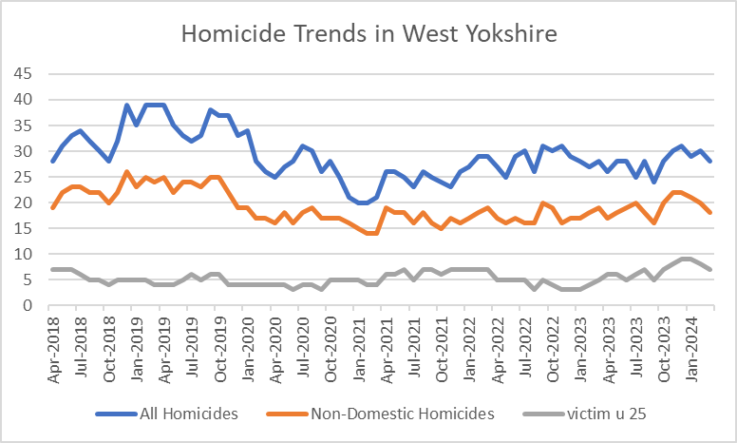

3.1.2 The above data shows the trends for all three crime types since 2018. Although the recent trend was increasing, this has now turned and is starting to decrease again.

3.1.3 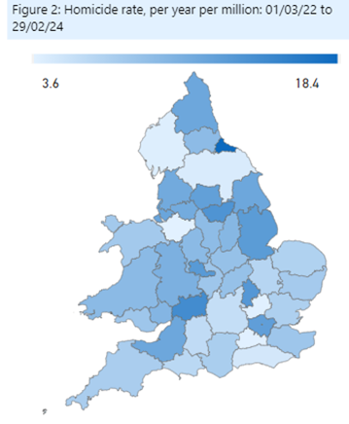

The long-term trends for Homicide rates (as shown in the map) evidence that West Yorkshire (12.6 per mil) has a similar rate to many in our MSG including GMP (11.3), West Mids. (13.2) and South Yorkshire (13.8).

**3.2 Reduce all hospital admissions for assault with a sharp instrument**

3.2.1 Hospital admissions are up to December 2023 and show no change for both groups.



**3.3 Reduce Knife Crime**

3.3.1 The undulating picture with knife crime can be seen in the below graph. There was a reduction during the pandemic and then a rise back to normal levels which reached their peak 2 years ago. The most recent two months have seen a slight decrease in these crimes. These are still well below the baseline figures.

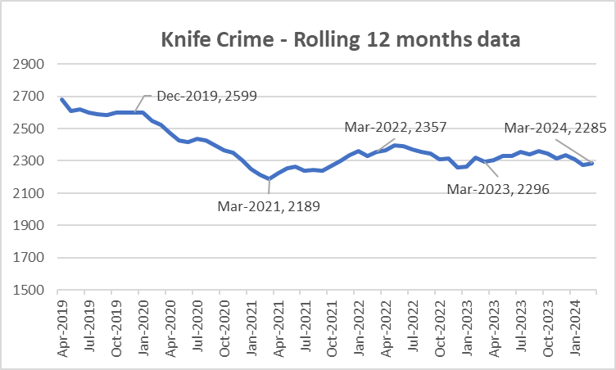

3.3.2 The most recent update nationally is to December 2023 – The below table looks at knife crime per million residents when compared to the Jan-Dec 2019 baseline. The below table compares with others in our most similar group.



3.3.3 It should be noted that West Yorkshire Police is one of 40 forces which uses a national methodology for recording knife crime. The remaining forces will be using the same methodology soon, but until then, national comparisons are problematic. Also, data for West Midlands is provisional due to a move to a new computer system.

**3.4 Reduce the number of ASB incidents**

3.4.1 Anti-Social Behaviour (ASB) incidents have increased slightly by 1.1% (309 incidents) when comparing the latest 12 months to March 2024 with the previous 12-month period.

3.4.2 The number of ASB incidents was significantly impacted by crime recording improvement activity. But now that difference is starting to slow as can be seen in the below graph.



3.4.3 Work has been undertaken with the Call Management Centre and the Neighbourhood Support Officers to ensure that West Yorkshire Police is better at identifying a crime from a victims / caller’s initial contact in relation to ASB.

**3.5 Keep Neighbourhood Crime below baseline**

3.5.1 In previous iterations of this document we have looked at the baseline of June 2019. More recent iterations of figures from the government look at this baseline as the 12 months to December 2019, so we have now changed to fall into line with this comparison.

3.5.2 Figures for the latest 12 months to March 2024 report that Neighbourhood Crime Offences have fallen by 26% when compared to the national baseline period (Jan-Dec 2019) equating to over 12,000 fewer victims. Notable reductions for residential burglary (down 37.7%), theft from person (down 23.4%) and theft from vehicle (down 39%) have been reported. For the first time since the end of the pandemic, total neighbourhood crime is lower than the previous year.

3.5.2 The below table looks at these crime types to break down the overall figures.



3.5.3 The one area that is different is Theft Of Motor Vehicle. This crime type continues to be the only one that is above the 12months to Dec 2019 baseline.

3.5.6 Compared with our most similar group, West Yorkshire has one of the largest % change in comparison to the baseline. (offences per 100,000 population).



**3.6 Monitor cyber-attacks on businesses via WYCA survey**

3.6.1 This data is not available currently.

**3.7 Increase proportion of workforce from ethnic minorities**

3.7.1 Overall the proportion of the total WYP workforce from ethnic minorities is at 8.5% but officers are currently above this at 9.6%. Although staff numbers are lower at 6.6% this is still an increasing trend.

3.7.2 As reported nationally, West Yorkshire Police exceeded its target for recruitment of officers and although the overall proportion of officers and staff from ethnic minorities continues to be below that of the West Yorkshire population, during recruitment this proportion was much higher and nearer to the target.

**3.8 Increase proportion of female officers**

3.8.1 West Yorkshire continues with high numbers of female officers - this has increased from 34% in 2018 to nearly 40% currently. Police staff continue to have a high number of female members, with that percentage not changing over the years.



3.8.2 The latest position in-Force in relation to faith, sexual orientation and disability of officers, staff and PCSO’s has been updated. Following work to address the completeness and accuracy of the data, the number of employees not recording their protected characteristics has fallen significantly from around 80% in 2021 to just 8% for officers, 6% for police staff and 5% for PCSOs.

**3.9 Reduce numbers of Killed or Seriously Injured on roads in West Yorkshire**

3.9.1 Numbers of KSIs on the roads in West Yorkshire is currently increasing and this is the focus of the Vision Zero meetings in West Yorkshire.

3.9.2 Please note that for all three charts below that 2023 data is provisional, pending verification by the DfT.

3.9.3 The overall trend for casualties of all severities shows an increase from pre-pandemic levels, with the number of people injured 14.2% higher in 2023 than 2019. However, there was a small decrease of 4.4% between 2022 and 2023.

3.9.4 The number of people killed or seriously injured in road traffic collisions has increased since the pandemic. There were 3.1% more people killed or seriously injured in road traffic collisions in West Yorkshire in 2023 compared to 2022. This number has increased 30.8% since 2019.

3.9.5 The number of people killed in 2023 was 24.6% lower than those killed in 2022, and 5.8% lower than the number killed in 2019. It should be noted that as these figures are much smaller, so there can be large fluctuations year on year.

3.9.6  When looking at the overall numbers by district, these have been compared to the current population figures (from 2021 census).



3.9.7 Each area now has a dedicated Vision Zero meeting where these numbers are scrutinised.

**3.10 Increase number of additional officers and staff in comparison to April 2021 baseline**

3.10.1 The numbers here show that officer numbers are increasing as expected, with staff numbers also increasing, even with the current budget constraints.

3.10.2 The Mayor and Deputy Mayor received a quarterly update for this measure to ensure that the Mayoral Pledge is met. This confirms that the pledge was met and surpassed.

3.10.3 Ongoing scrutiny by the Mayor ensures that the frontline is supported and upheld by the increasing numbers of officers as they become available for frontline duties (i.e. after the classroom learning is completed).

**4. Responding to Multiple and Complex Needs**



**4.1.1 Monitor VRU early intervention programme attendee figures**

4.1.2 As part of its monitoring information for the Home Office, the Violence Reduction Partnership must show the impact of its work by counting the number of young people (and others) that it reaches.

4.1.3 The VRP sends these figures quarterly to the Home office to show the impact of its interventions. These interventions have been detailed in previous papers to the panel and will continue to be part of the impact of the Police and Crime Plan.

**4.2 Reduce the number of repeat missing persons.**

4.2.1 Number of Missing persons per 1,000 population.

Over the last 12 months there have been 9,741 missing persons (including repeats). The trends for this are as follows.

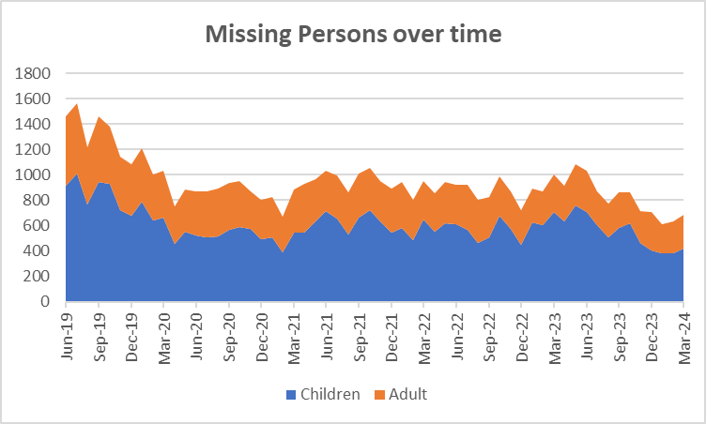



4.2.2 The next table looks at the numbers of repeat missing occurrences.

4.2.5 The number of repeat missing persons is detailed above. This stands at 35.9% for missing children and 12.4% for missing adults.

**4.3. Reduce Re-offending Rate for Drug Related Crime**

4.3.1 Due to the time lapse required to ensure offences are taken into consideration, the re-offending rates are for offenders who were convicted 12 months ago.

4.3.2 The current figures show that there has been a 0.4% reduction in this rate in comparison to the same time 12 months ago.

4.3.3 Work is ongoing with the Senior Responsible Officers for the Combatting Drugs WY partnership with the Deputy Mayor bringing all 5 districts together to discuss common problems and share best practice.

4.3.4 West Yorkshire Reducing Reoffending Partnership Board: This is the current iteration of the board convened by the Mayor and chaired initially by the Criminal Justice Policy Manager. The intention of this board is to add value to existing Reducing Reoffending Partnerships within districts and their work with Criminal Justice partners including Youth Justice.

**4.4 Reduce the number of First-time entrants to the CJS**

4.4.1 Following a user consultation published in February 2023, the MOJ have concluded first time entrants’ statistics will only be published annually as part of the First-time entrants (FTE) into the Criminal Justice System and Offender Histories publication.

**4.5 Increase number of offenders referred to drug treatment services via Liaison and Diversion**



4.5.1 Figures relate to referrals to drug services across the five districts. Figures provided by West Yorkshire All Age Liaison and Diversion Service.

4.5.6 Referrals are up for both adults and young people, but there has been a reduction in formal pathway referrals and other pathway contacts. Areas are looking at other pathway contacts to enhance this data from partners.

Appendix 2

**Cyber Crime**

**Reports, referrals, and outcomes for**

The below data is for April 2023 – March 2024

Cyber Crime reporting

The above is for Cyber Crime only the picture for Fraud is as follows:

.

For business Cyber Crime **only** the current picture is as follows:

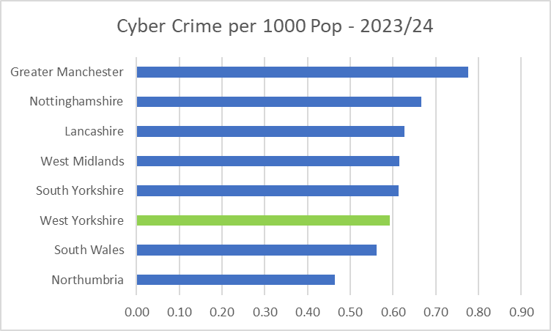

|  |  |
| --- | --- |
| **Acquisitive crime** | Acquisitive crime is defined as an offence where the offender derives material gain from the crime. Examples include shoplifting, burglary, theft, and robbery. |
| **BAME** | BAME stands for Black, Asian and Minority Ethnic and is used to describe people from any of these ethnicities. |
| **Child sexual exploitation and abuse** | Sexual exploitation of children and young people under 18 involves exploitative situations, contexts, and relationships where young people (or a third person or persons) receive 'something' (e.g., food, accommodation, drugs, alcohol, cigarettes, affection, gifts, money) because of them performing, and/or another or others performing on them, sexual activities. |
| **Community Safety Partner** | Several different organisations have a role to play including local councils, fire and rescue service, health and probation services and housing providers etc. These are often referred to as local community safety partners. |
| **Conviction rate** | This measure is calculated by dividing the number of defendants convicted by the total number of defendants prosecuted in the court during the period in question. The total number of defendants prosecuted in the court includes those charged by the police and Crown Prosecution Service but whose cases were dropped. |
| **Crime rate** | The crime rate used in this document refers to the number of offences committed per 1000 people in the population. |
| **Cyber crime** | Can be seen in two parts: cyber-enabled crime, where crimes that may be committed without computers are instead committed using computer networks (for example fraud and bullying); and pure cyber-crime where the offence can only be committed using computers (for example computer hacking or use of malicious software). |
| **GAP**  **Human trafficking** | Anticipated Guilty Plea  Human trafficking is the trade of humans, most commonly for the purpose of forced labour or commercial sexual exploitation by the trafficker or others. |
| **IOM** | Integrated Offender Management (IOM) is an overarching framework that allows local and partner agencies to come together to ensure that the offenders whose crimes cause most damage and harm locally are managed in a coordinated way. |
| **Ineffective trial** | An ineffective trial occurs when the trial does not go ahead on the date planned due to action or inaction by one or more of the prosecution, the defence or the court and a further listing for a trial is required. |
| **Most similar police groups/family/forces**  **NGAP** | Most Similar Groups (MSGs) are groups of police force areas that have been found to be the like each other based on an analysis of demographic, social and economic characteristics which relate to crime. Each police area has its own group of up to seven police areas to which it is ‘most similar’. MSGs are designed to help make fair and meaningful comparisons between police areas which share similar characteristics, rather than, for example, comparisons with a neighbouring police area.  Anticipated Not Guilty Plea |
| **Operational functions** | Operational functions include things like patrolling neighbourhoods, responding to 999 calls, roads policing and protecting vulnerable people. |
| **Outcomes/detections** | Outcomes/detections are used by the Home Office to describe the result of a police investigation following the recording of a crime. They can include cautions, charges, fixed penalty notices, cannabis warnings etc. There are 21 categories of outcomes. |
| **PEEL**  **Positive Outcomes** | HMICFRS carry out several thematic annual inspections throughout the year, these are drawn together into a wider PEEL assessment which stands for Police Effectiveness, Efficiency and Legitimacy. The aim of the PEEL assessment is to judge each police force in a cross-topic way based on criteria which consider the full breadth and complexity of what the police do.  Outcomes which fall into the first 8 categories for Police outcomes, these include mostly charges, cautions and community resolutions. |

**Find out more.**

westyorks-ca.gov.uk

@WestYorkshireCA

enquiries@westyorks-ca.gov.uk

+44 (0)113 251 7272

All information correct at time of print (October 24)