**If you or someone you know has been raped, sexually assaulted** **or abused, support is available from specialist organisations in your local area and across Yorkshire and the Humber**

**The services do not decide for you or tell you what to do. You will be listened to, and the services can talk to you about your options.**

**Medical support and advice will be offered, and you can have forensic samples taken by trained staff, which will be stored safely and confidentially for you.**

**Preserving evidence: what you need to know**

When you contact the SARC, they will give you advice on what you can do to help preserve evidence before a forensic medical examination.

It is recommended that you **do not take** a swab yourself, as this could impact the ability of the SARC to capture a DNA sample and provide the required evidence to the police. You can read about the risks of doing this in a [Joint Statement on self-swabbing kits](https://fflm.ac.uk/wp-content/uploads/2024/09/Joint-Position-statement-on-forensic-self-swab-services-after-sexual-assault-or-rape-with-FAQ-10-09-2024-v3.pdf), which has been published by the Faculty of Forensic and Legal Medicine with support from other medical and forensic expert organisations.

**Sexual Assault Referral Centre Services (SARCs)**

If you have been raped, sexually assaulted or abused, you can contact your nearest SARC for free, specialist care and support in a safe space.

You can get help from a SARC without having to talk to the police or report what happened to you – you decide at each stage.

If you have been raped, sexually assaulted or abused within the last seven days, you will be offered a forensic medical examination. This is where a doctor or nurse collects evidence, including swabs, from your body and clothes.

It is your choice whether to have a forensic medical examination and having one doesn't mean you have to report to the police. If you decide to have a forensic medical examination, the SARC will ensure that any evidence gathered follows the national guidance for collection, movement and storage of DNA evidence.

A SARC will **not** ask you to use a self-swab kit as part of a forensic medical examination.

If you’re not sure about reporting to the police, you can have the examination and the evidence can be safely stored, giving you time to decide what to do.

If you decide to report to the police in the future, this evidence can then be shared with them.

**Facts about SARCs in Yorkshire and the Humber.**

* If you are aged 16 and above you can contact the SARC yourself for free, confidential healthcare and compassionate support. You do not need to report to anyone else if you don’t want to.
* There is a SARC in each police force area
  + Humberside - CASA Suite website [https://casasuite.org/](https://url.uk.m.mimecastprotect.com/s/Qbw_Cv27kf7jGL5tQf5TQrRkz?domain=casasuite.org/)
  + North Yorkshire - Acer House [https://acerhousesarc.co.uk/](https://url.uk.m.mimecastprotect.com/s/PeP-Cwp8lCGz7VmiqhmTJCHXr?domain=acerhousesarc.co.uk/)
  + South Yorkshire - Hackenthorpe Lodge [https://hackenthorpelodge.org/](https://url.uk.m.mimecastprotect.com/s/eL8cCxkNmS14yRVHYiQTys42X?domain=hackenthorpelodge.org/)
  + West Yorkshire - Hazlehurst Centre [https://hazlehurstcentre.org/](https://url.uk.m.mimecastprotect.com/s/QEaKCyPOnirzg2wIRsRTxSuz2?domain=hazlehurstcentre.org/)

**Our SARCs offer free and confidential advice – call Mountain Healthcare on 0330 233 0938  
they are open 24 hours a day, every day of the year.**

**You will speak with a nurse for support and to discuss your options for making an in-person appointment and/or referral.**

* There is an opportunity to gather forensic evidence, including DNA, for **up to seven days after** being raped, sexual assaulted or abused.
* The team can advise and support you with any health needs and concerns, including emergency contraception and sexually transmitted infection prevention.
* The team can also make sure you receive appropriate care for any physical injuries.
* If you choose not to report to the police, you have the option of making an ‘anonymous report’. This information can be logged by the police, without knowing your name or any other identifying information. Some people find this helpful.
* The team are specialists in their field and are trained to provide trauma-informed support to anyone of any age or gender who has been raped, sexually assaulted or abused.
* The SARC will never share your data and personal information with anyone else without your consent, unless we believe that either you or someone else is at risk of significant harm.
* The SARC can help you access other local, free, specialist services these services might include mental health/counselling, sexual health, your GP, or the local Independent Sexual Violence Advisor (ISVA) service. These services are available to anyone, regardless of whether you have chosen to report to the police or not.

**Signed**

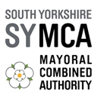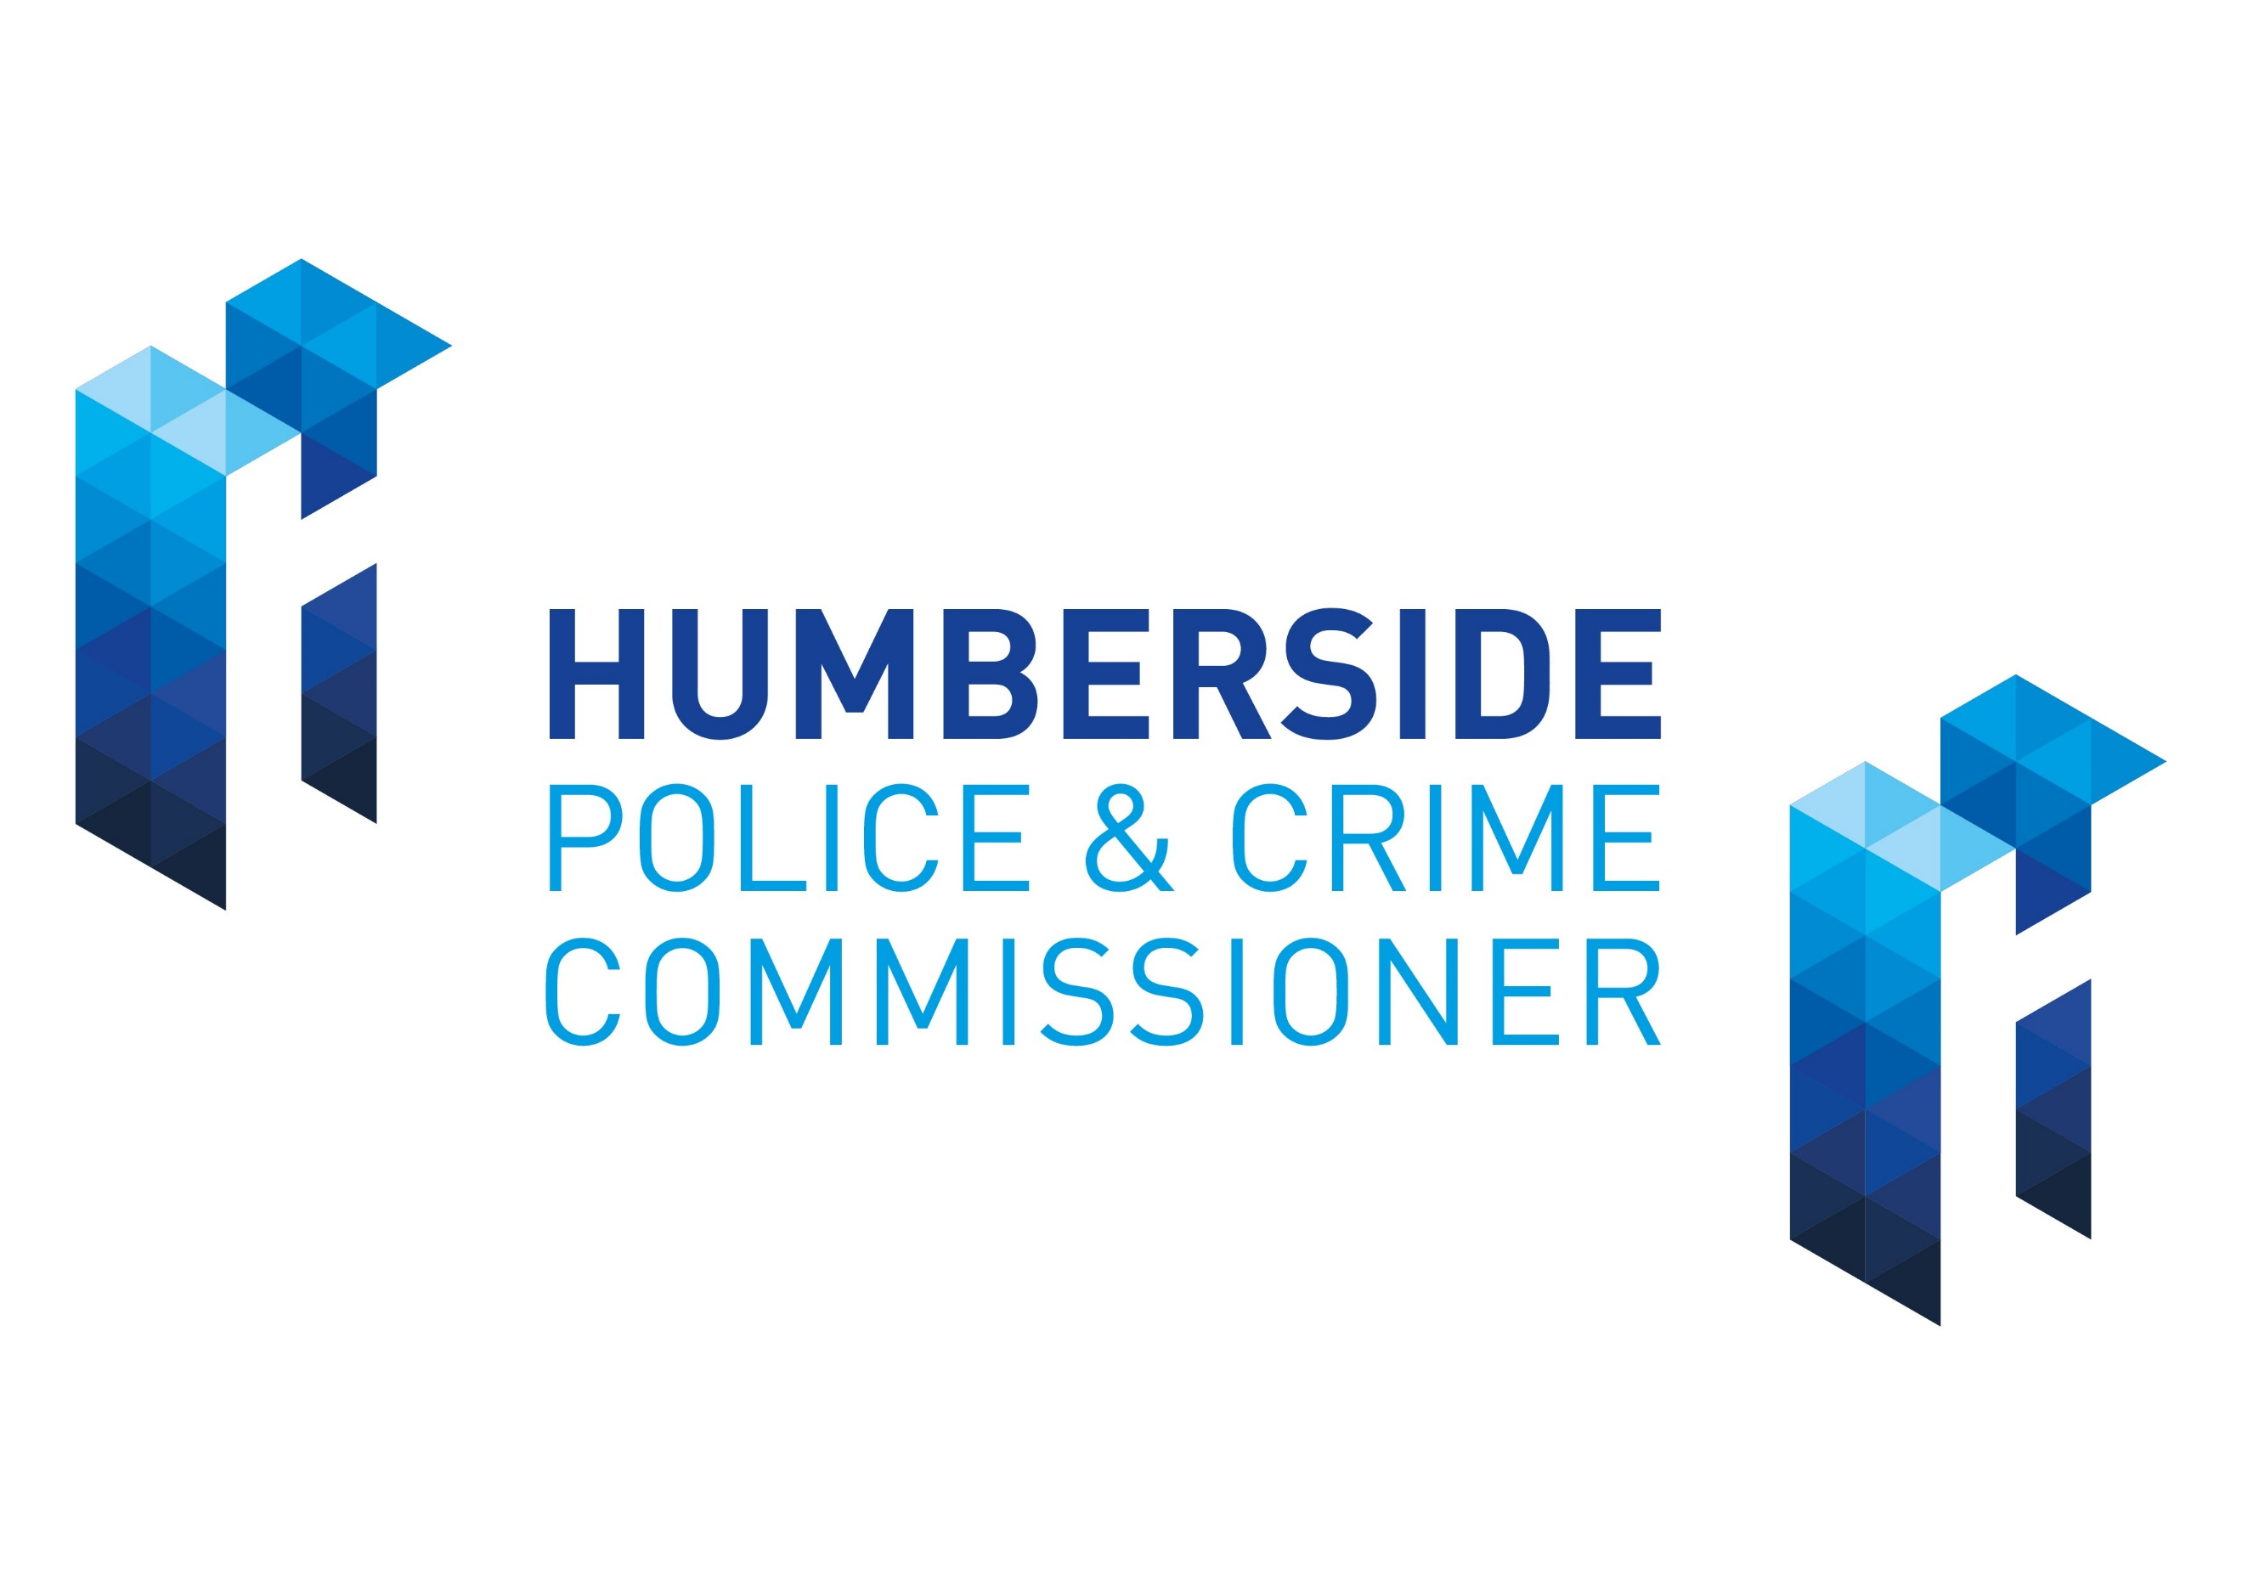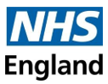

**Additional information**

* NHS animation about SARCs: https://youtu.be/Et6Ja2eCW6E
* SARCs provide a safe space and dedicated care for anyone who has been raped, sexually assaulted or abused. They are available to everyone, regardless of when the incident happened and whether someone chooses to involve the police.
* SARCs are located across the country and offer specialist practical, medical and emotional support, in Yorkshire and the Humber they are open 24 hours a day, 7 days a week. This includes crisis care, medical and forensic examinations, emergency contraception and testing for sexually transmitted infections. They can also arrange access to an independent sexual assault advisor, as well as referrals to mental health support and voluntary sector sexual violence support services. Access to a SARC is by appointment and individuals can self-refer or ask a health care professional, family member, friend or other representative to refer them.
* Visit www.nhs.uk/SARCs for more information on help after rape, sexual assault and abuse.