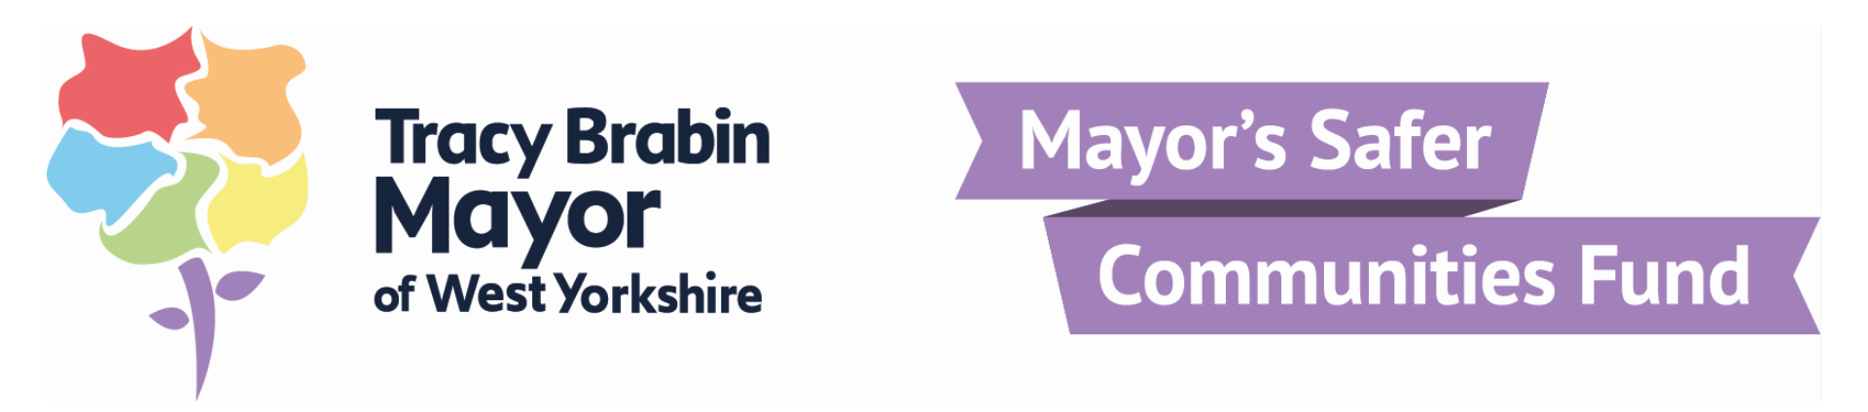
Final Evaluation Report
2021-22

As part of the Safer Communities Fund process, you are required to complete the following evaluation forms once your project has concluded.
The terms and conditions of the grant which you accepted refer to this detail and can be found here.
A full list of the priorities and outcomes listed in the Police and Crime Plan can be found here.
Please complete this form and return to the West Yorkshire Combined Authority Policing and Crime Team. Please note the office will review this in line with your successful application.
safercommunitiesfund.pc@westyorks-ca.gov.uk

The Engagement Team, at Ploughland House, 62 George Street, Wakefield, WF1 1DL

To be completed by a member of the Engagement Team.
Name of Organisation
Name of Project
Grant Round Awarded |  |  | Date Awarded:
Total Grant |  |  | Number of beneficiaries
Priorities/ Theme: |  |  | Outcomes:
Project Description:

Was the project completed on time?
Either as predicted in your original application form or within the maximum 12 month period. Please detail any project extensions required.

Was the project completed on ‘budget’?
Referring to the total value on page 1 and the financial breakdown provided in your original application form, were some figures in the financial breakdown altered, did your project exceed these costs, overall costs or underspend providing reasons for each.

Did your project meet the priorities indicated? Please provide an example/evidence of each.
Referring to the Police and Crime Plan priorities listed on page 1, did your project make a positive difference towards them; providing an example per priority.

Did your project meet the outcomes indicated? Please provide an example/evidence of each.
Referring to the Police and Crime Plan outcomes listed on page 1, how did your project contribute to each outcome; providing an example per outcome

Did you face any barriers or challenges in completing this project?

How many beneficiaries did your project engage with?
Referring to the estimate quoted in your original application form and listed on page 1, please provide details on how this number was met or why it was not achieved

Did you feel your project had a wider impact on your community?
If so, can you provide examples of this

If your project is part of a longer term programme, how do you plan to sustain this work?

Did you work with any partners during this project?
Including those listed in your original application form, please provide details of partners and activities

Did you do any social media or publicity around your project?
Please include any links to posts or newspaper articles if available.

Please tell us about any difficulties which you may have faced throughout the SCF grant, suggesting any improvements we could make to the process going forward.

Any other comments…

Signed :

End of Year Financial Monitoring 2021/22
(to accompany the Final Evaluation Report)
Project Breakdown
In relation to the project breakdown you provided in the original application form, please describe how the monies was spend. If there have been variances in estimated costs, please describe.
Item | Estimated Spend | Actual Spend | Difference

TOTAL EXPENDITURE
TOTAL GRANT PROVIDED
VARIANCE: total grant minus total resource expenditure

You must pay back any underspend as per the terms and conditions of the grant which can be found here. Please contact us for our account details.

TREASURER, FINANCE OFFICER OR EQUIVALENT CERTIFICATION
I certify to the best of my knowledge and belief that
- The information provided is correct; and no other Exchequer grants, other grants or contributions have been or will be payable for the expenditure in respect of the grant being claimed;
- The expenditure has been incurred only for the purposes set out in the terms and conditions of the grant agreement for the above grant stream.

Signature
Name (printed)
Position
Date

