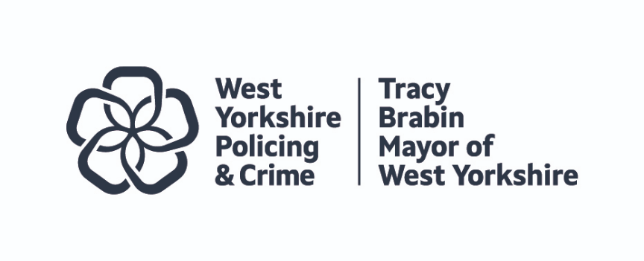


JOINT INDEPENDENT AUDIT COMMITTEE WORKPLAN
(THE MAYOR FOR WEST YORKSHIRE AND WEST YORKSHIRE POLICE)

AUDIT CYCLE
Q1 SPRING | Q2 SUMMER
West Yorkshire Police  - Business Update  - Tender Exception Report  - Risk Management Update  - Internal Audit Progress Report  - Internal Audit Follow Up Report  - Internal Audit Strategy, Charter & Plan  - Business Interests, Gifts & Hospitality  - FOI/DPA Governance Report | West Yorkshire Police  - Business Update  - Tender Exception Report  - Risk Management Update  - Internal Audit Progress Report  - Internal Audit Follow Up Report  - Internal Audit Annual Report and Opinion  - Draft Annual Accounts, including the Annual Governance Statements  - Force Management Statement  - Assurance Framework
WYCA Policing and Crime Team  - Business Update  - Risk Management Update  - Treasury Management Strategy Report  - Sponsorship Report  - Business Interests, Gifts & Hospitality  - FOI/DPA Governance Report | WYCA Policing and Crime Team  - Business Update  - Risk Management Update  - Draft Annual Accounts, including the Annual Governance Statements (information only).  - Assurance Framework
External Audit  - External Audit Progress Report | External Audit  - External Audit Strategy Memorandum 2024/25
Q3 AUTUMN | Q4 WINTER
- Review of Committee Terms of Reference and Workplan | - Committee Annual Report and Self-Assessment
West Yorkshire Police  - Business Update  - Tender Exception Report  - Risk Management Update  - Internal Audit Progress Report  - Internal Audit Follow Up Report  - Internal Audit Self-Assessment against the PSIAS  - Force Budget Planning | West Yorkshire Police  - Business Update  - Tender Exception Report  - Risk Management Update  - Internal Audit Progress Report  - Internal Audit Follow Up Report  - Anti-fraud and Anti-corruption Strategies  - Internal Audit of Information Systems Asset Management Devices  - Review of Draft Accounting Policies
WYCA Policing and Crime Team  - Business Update  - Risk Management Update  - Annual report and Review of the Scheme of Delegation and Scheme of Consent. | WYCA Policing and Crime Team  - Business Update  - Risk Management Update  - Commissioning and Grants Strategy
External Audit  - External Audit Completion Report 2023/24 (ISA 260 findings report) and Annual Report 2023/24. | External Audit  - External Audit Progress Report
Additional Coverage
NPAS | Organisational transitional arrangements | Internal Audit appointment processes and performance

