
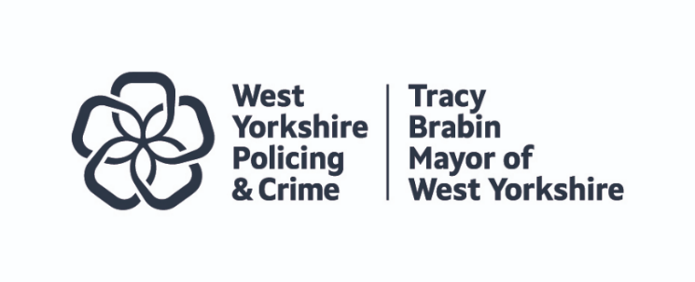
Discussion at: | Joint Independent Ethics Committee (JIEC)
JIEC Date: | 27 November 2024
Subject/ Dilemma: | Suspended and Restricted whilst under investigation
Report of: | West Yorkshire Police
Presenter: | Tanya Wilkins

- PURPOSE

  - To get independent advice and opinion from the Joint Independent Ethics Committee Members to inform and influence decision making.

  - For JIEC Members to highlight areas of focus for the Mayor, Deputy Mayor and Chief Constable to consider.

- SUMMARY

2.1 The Professional Standards Directorate (PSD) is responsible for maintaining integrity and upholding ethical standards within the organisation. It plays a critical role in ensuring that police forces operate with integrity, maintain public trust, and are held accountable for their actions, contributing to a fair and just policing system.
The PSD investigates allegations of police officers' and staff misconduct, unethical behaviour, or criminal activity, both on and off duty. This includes incidents such as corruption, abuse of power, discrimination, and any breaches of professional conduct.
They also investigate reports involving excessive use of force, discrimination, harassment, or dishonesty.
If officers and staff are being investigated for breaches of conduct that amount to gross misconduct (a breach so serious that it justifies dismissal), they may be assigned to restricted duties. This typically involves limiting their involvement in criminal investigations or public-facing roles. Alternatively, they may be placed on suspension with full pay during the investigation.

Suspension may be considered under the following circumstances:
- A temporary reassignment to a new location or role has been considered but deemed inappropriate given the situation, or
- Either the effectiveness of the investigation could be compromised if the officer is not suspended, or
- It is deemed to be in the public interest, due to the seriousness and nature of the allegation, that the officer be suspended.
Suspension or restricted status is reviewed every 28 days to assess whether it remains necessary, or if suspension should be considered due to developments in the investigation. For instance, if the officer/staff is charged with a criminal offence, suspension from duty is typically implemented.

- KEY QUESTIONS/ SPECIFIC AREAS OF FOCUS FOR THE COMMITTEE

3.1 I would like the panel to consider the below questions: -

- Should officers and staff be allowed to remain at work while on restricted duties, performing tasks that do not involve direct public interaction or access to sensitive information?
- What would be the impact on the organisation if the public perceives that officers and staff under investigation for serious misconduct are allowed to remain at work?
- Should officers and staff who are charged with criminal offences be suspended?

3.2 Members discussed the topic at length. Discussion summary:

- It is felt that WYP are doing the right thing with current process and practices.
- If officers and staff are not suspended or put on restricted duties, the public perception, trust and confidence in the service will decline.
- WYP should focus on getting matters resolved as quickly as possible. If people are away from work for an extended period of time, this can impact their feeling of being able to come back into the organisation and they may then leave.
- It is acknowledged that there will always be one off instances which shine a light on the issue and trigger public debate on suspending from duties; and these instances should be accepted for what they are [rare]. These cases do not mean that the underlying policy is wrong.
- More work should be done to look at the context of internal disproportionality. Is it zero tolerance for all, or do certain groups get given more tolerance. Fairness needs to be considered in the system as although PSD shows zero tolerance, if there is disproportionality in those that are sent to PSD, it means that this zero tolerance is applied unfairly.
- Review the communication strategy to help members of the public understand the difference between a what will be dealt with as a complaint and the misconduct threshold, to help manage public expectations.
- Safeguarding, public trust and confidence, and swift resolutions should be at the heart of the process.
- Members agreed that it is entirely justified to suspend when person is charged with an offence as allowing to continue in work could cause reputational damage even if acquitted later down the line.

