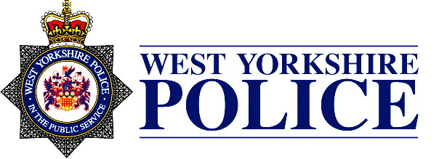
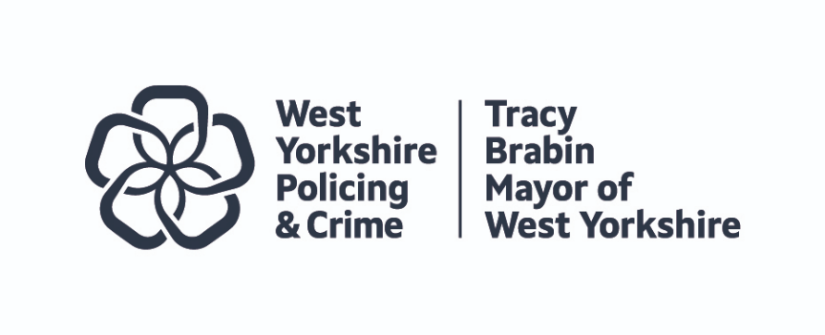
Joint Independent Audit Committee Terms of Reference
with effect from 16 October 2024
Statement of Purpose
- The Joint Independent Audit Committee is a key component of corporate governance for West Yorkshire Police and the Mayor’s Police and Crime Commissioner (PCC) functions. It provides an independent and high-level focus on the audit, assurance and reporting arrangements that underpin good governance and financial standards.

- The purpose of the Joint Independent Audit Committee is to provide independent advice and recommendation to the Mayor and the Chief Constable on the adequacy of the governance and risk management frameworks, the internal control environment and financial reporting, thereby helping to ensure efficient and effective assurance arrangements are in place. To this end the committee is enabled and required to have oversight of, and to provide independent review of, the effectiveness of West Yorkshire Police and the Mayor’s governance, risk management and control frameworks, the financial reporting and annual governance processes, internal audit and external audit.

- These terms of reference will summarise the core functions of the committee and describe the protocols in place to enable them to operate independently, robustly and effectively.

Governance, Risk and Control
The committee will provide advice and recommendations to the Mayor or Chief Constable in relation to the following areas:

Chief Constable
- Review the corporate governance arrangements against the good governance framework, including the ethical framework and consider the local code of governance.
- Review the annual governance statement prior to approval and consider whether they properly reflect the governance, risk and control environment and supporting assurances and identify any actions required for improvement.
- To consider whether the annual evaluation for the AGS fairly concludes that governance arrangements are fit for purpose
- Consider the arrangements to secure value for money and review assurances and assessments on the effectiveness of these arrangements.
- Consider the framework of assurance and ensure that it adequately addresses the risks and priorities of the Chief Constable.
- Monitor the effective development and operation of risk management, review the risk profile, and monitor progress of the Chief Constable in addressing risk-related issues reported to them.
- To consider reports on the effectiveness of financial management arrangements, including compliance with CIPFA’s Financial Management Code.
- Consider reports on the effectiveness of internal controls and monitor the implementation of agreed actions.
- Review arrangements for the assessment of fraud risks and potential harm from fraud and corruption and monitor the effectiveness of the counter fraud strategy, actions and resources.
- To monitor the counter fraud strategy, actions and resources.
- To review the governance and assurance arrangements for significant partnerships or collaborations.
- To be updated on the overall conclusions of external inspections/assurance reports and the implementation of related improvement plans. The committee will also consider how the work of these assurance providers is taken into account in the work of external audit or internal audit
- To receive requests from, and provide advice to the Assistant Chief Officer and Head of Internal Audit in West Yorkshire Police.
- To receive regular presentations/reports from officers responsible for the management of significant risks.

Mayor (PCC functions)
- Note the annual governance statement of the Combined Authority and provide observations on the section of the governance statement which relates to the Mayor’s PCC functions.
- Review treasury management policies, practices and activities for the oversight of the Police Fund including an annual strategy and plan, an assessment of the treasury risk profile and risk management processes..
- Consider the framework of assurance and ensure that it adequately addresses the risks and priorities of the Mayor.
- Monitor the effective development and operation of risk management relating to the Mayor’s police and crime duties, review the risk profile, and monitor progress of the Mayor in addressing risk-related issues reported to them.
- To review the governance and assurance arrangements for significant partnerships or collaborations.
- To receive requests from, and provide advice to, the Director of Corporate Services (S73 Officer) and the Head of Legal and Governance (Monitoring Officer) in the Combined Authority.
- To report to the Combined Authority’s Governance and Audit Committee on members observations on arrangements to secure value for money in terms of the Mayor’s PCC functions, including commissioning and grant-aiding arrangements for delivery of the Police and Crime Plan.
- To receive regular presentations/reports from officers responsible for the management of significant risks.

Internal Audit
The committee will provide observations, advice and/or recommendations to the Mayor or Chief Constable in relation to the following areas:

Chief Constable
- Annually review the internal audit charter and resources and raise any significant changes.
- Review the internal audit plan and any proposed revisions to the internal audit plan.
- Take account of internal audit’s resource requirements, the approach to using other sources of assurance and any work required to place reliance upon those other sources.
- Oversee the appointment process and consider the adequacy of the performance of the internal audit service and its independence.
- Consider the Head of Internal Audit’s annual report and opinion, and a regular summary of the progress of internal audit activity against the audit plan, and the level of assurance it can give over corporate governance arrangements.
- To consider the Head of Internal Audit’s statement of the level of conformance with the Public Sector Internal Audit Standards (PSIAS) and the results of the Quality Assurance Improvement Programme (QAIP) that support the statement – these will indicate the reliability of the conclusions of internal audit.
- To also consider the external quality assessment of internal audit that takes place at least once every five years.
- To make appropriate enquiries of both management and the head of internal audit to determine if there are any inappropriate scope or resource limitations.
- Consider summaries of internal audit reports and such detailed reports as the committee may request from the Chief Constable, including issues raised or recommendations made by the internal audit service, management response and progress with agreed actions with due consideration to the level of risk being accepted by management.
- Consider a report on the effectiveness of internal audit to support the West Yorkshire Police Annual Governance Statement, where required to do so by the Accounts and Audit Regulations (England) 2015.
- To consider any impairments to independence or objectivity arising from additional roles or responsibilities, outside of internal auditing, of the Head of Internal Audit. To make recommendations on safeguards to limit such impairments and periodically review their operation.
- The provide the Head of Internal Audit free and unfettered access to the Audit Committee Chair as well as the opportunity for private meetings with the Committee

Mayor (PCC functions)
- Consider summaries of internal audit reports and such detailed reports as the committee may request which relate to the Mayor’s PCC functions, including issues raised or recommendations made by the internal auditors, management response and progress with agreed actions.
- To provide observations to the Combined Authority’s Governance and Audit Committee on arrangements for and the effectiveness of any collaboration arrangements between the respective Internal Audit teams in the Combined Authority and West Yorkshire Police.

External Audit
The committee will provide observations, advice and/or recommendations to the Mayor or Chief Constable in relation to the following areas:

Chief Constable
- Support the independence of external audit through consideration of the external auditor’s annual assessment of its independence and review of any issues raised by either Public Sector Audit Appointments or the auditor panel as appropriate.
- Comment on the scope and depth of external audit work, its independence and whether it gives satisfactory value for money.
- Consider the external auditor’s annual management letter, relevant reports and the report to those charged with governance.
- Consider specific reports as agreed with the external auditor.
- Advise and recommend on the effectiveness of relationships between external and internal audit and other inspection agencies or relevant bodies.
- To advise on commissions of additional work from external audit.
- The provide the auditors free and unfettered access to the Audit Committee Chair as well as the opportunity for private meetings with the Committee

Mayor (PCC functions)
- Provide observations to the Combined Authority’s Governance and Audit Committee on external audit work in West Yorkshire Police including it’s independence, annual management letter and specific reports.

Financial reporting
The committee will provide observations, advice and/or recommendations to the Mayor or Chief Constable in relation to the following areas:

Chief Constable
- Review the annual statement of accounts. Specifically, to consider whether appropriate accounting policies have been followed and whether there are concerns arising from the financial statements or from the audit of the financial statements that need to be brought to the attention of the Chief Constable.
- Consider the external auditor’s report to those charged with governance on issues arising from the audit of the financial statements.
To monitor the arrangements and preparations for financial reporting to ensure that statutory requirements and professional standards can be met.
Mayor (PCC functions)
- Provide observations to the Mayor and to the Combined Authority’s Governance and Audit Committee on West Yorkshire Police’s annual statement of accounts and any issues arising from the audit of the financial statements.

Accountability arrangements
Through its committee meetings the committee will deliver the following:
Chief Constable
- On a timely basis report to the Chief Constable with its advice and recommendations in relation to any matters that it considers relevant to governance, risk management, internal control frameworks, internal and external audit functions, financial reporting arrangements and financial management.

Mayor (PCC functions)
- On a timely basis report to the Mayor with its advice and recommendations in relation to any matters that it considers relevant to governance, risk management and financial management for the Mayor’s PCC functions and also for West Yorkshire Police.

In addition the committee will:
- Review its performance against its terms of reference and objectives on an annual basis and report the results of this review to the Mayor and the Chief Constable.

- Report annually to the Combined Authority’s Governance and Audit Committee and provide the approved minutes after each meeting.

- Publish an annual report on the work of the committee.

Constitution
4 members independent of the Mayor and the Chief Constable, one of whom is the appointed Chair.
Quorum
3 members, including the Chair. In the absence of the Chair members present will appoint a Chair for that meeting.

Where references are made to the Mayor in this document these relate to the Mayor’s Police and Crime Commissioner (PCC) functions

