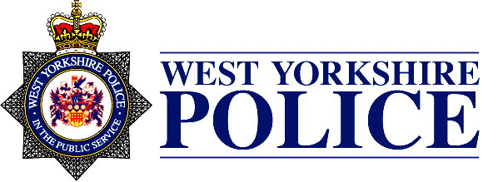
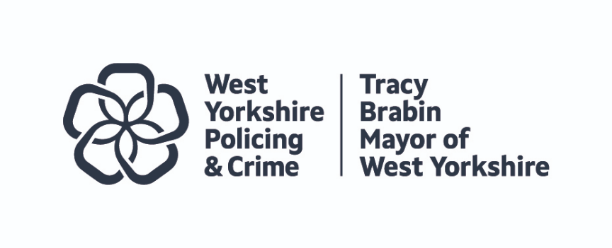
WEST YORKSHIRE JOINT INDEPENDENT ETHICS COMMITTEE
TERMS OF REFERENCE

PURPOSE
To help build trust and public confidence in policing by engaging in meaningful debate on ethical issues facing the West Yorkshire Mayor and West Yorkshire Police, acting as a ‘critical friend’ and providing independent expert advice to the Mayor and the Chief Constable to assist them in ensuring that the Force aspires to, and achieves, the highest levels of integrity and standards of service delivery.
The focus of the deliberation will be on current and planned activities.
The Mayor or Chief Constable may refer to the Committee any matter which they consider impacts or may impact on the effectiveness and efficiency of the police and the broad public consent for policing and they may also commission specific pieces of work from the Committee.
The Committee will issue reports on matters placed before it or, where appropriate and requested, issue a letter of advice on a specific matter. Where possible, reports will be published.
The Committee will set an annual work programme, approved by the Mayor following consultation with the Chief Constable.
The Committee will be provided with information held by the Police and the Mayor and members will have appropriate security clearance. The Committee may invite any employee or officer of the Force or the Mayor’s Office to provide information.

SCOPE
The Committee will focus on the ethical implications of current and planned work in West Yorkshire Police which have an impact on individual rights, which may include, but need not be limited to:
- Data analytics, the use of information and digital technological developments, including AI (Artificial Intelligence) and predictive policing
- Facial recognition, biometrics and surveillance
- Human rights issues, including equity, diversity and inclusion, use of force and Stop and Search
It is not within the Committee’s scope to provide legal advice. Members should be aware that any advice provided may be disclosable in legal proceedings or regulatory action involving West Yorkshire Police.
In order to discharge the agreed annual work programme, and following the agreement of the Mayor and the Chief Constable via a Governance Meeting, the Committee may invite reports from the Chief Constable and the Mayor and will also receive relevant HMICFRS, IOPC (Independent Office for Police Conduct) and ICO (Information Commissioner’s Office) reports as well as reports from national ethics/data ethics/biometric and forensics fora hosted by the APCC (Association of Police and Crime Commissioners), NPCC (National Police Chiefs’ Council), College of Policing or Government bodies such as the Centre for Data Ethics and Innovation. The Committee may also receive reports, or contribute to discussions in, the Combined Authority’s Scientific Support Panel. The Committee may accept referrals from the Force Internal Ethics Committee, but individual cases will not be scrutinised.
Where other scrutiny and accountability mechanisms produce relevant reports and discussions these will be shared with the Committee, for example, from stop and search scrutiny groups or independent advisory groups in West Yorkshire Police.
The Committee will report regularly to the Mayor and Chief Constable and provide them with an annual report of the Committee’s work and will publish discussion summaries which should also be shared with the Joint Independent Audit Committee and the Force Internal Ethics Committee.
Members will be under a strict obligation to maintain the confidentiality of matters that are deliberately not disclosed as part of the Ethics Committee records.
The Ethics Committee is to act independently and free of bias, including political bias.

MEETINGS
Quarterly in private. Discussion summaries will be published along with specific reports at the Chair’s request. Meetings will be supported by the Mayor’s Policing and Crime Team

MEMBERSHIP
Chair – paid position with relevant qualification or significant experience in ethical governance or human rights
Independent members, paid positions, drawn from a range of disciplines including legal, academia, criminal justice and health.
The committee will be formed of 5 members, appointed by the Mayor and the Chief Constable (or their representative) following a formal application and interview process.
All reasonable endeavours will be made to appoint members who are, as far as possible, representative of the diverse communities of West Yorkshire.
Members of the Committee should live or work in West Yorkshire and must disclose any conflicts of interest before appointment or during their tenure.

