MAYOR FOR WEST YORKSHIRE
RESPONSE TO THE POLICE AND CRIME PANEL

I would like to thank members of the Police and Crime Panel for carefully considering my precept proposal on 7 February 2025 and voting to endorse an increase of 5.6% so that we can continue to invest in the future of policing and community safety in West Yorkshire.

The proposal was supported by 58% of respondents to my survey and means a £14 a year increase on Band D properties with approximately 61% of Council Taxpayers paying less than 27 pence a week more.

As part of its approval, the Panel has sought assurance on the following commitments to:
- Work with West Yorkshire Police to retain and increase the numbers of PCSOs where funding allows
- Update the Panel on the progress of Priority Based Budgeting, ensuring that the necessary efficiencies are on track to meet projected funding shortfalls. Additionally, outline contingency plans if these efficiencies are not achieved
- To report back mid-year on the reserves position providing assurances that these are maintained at a sustainable level and reduce the reliance on reserves going forward
- Initiate the 2026/27 budget consultation early, providing an extended timeframe and continuing to aim for wider engagement from all community sectors
I am pleased to confirm my commitment to:
- Work with West Yorkshire Police to retain and increase the numbers of PCSOs where funding allows
- Update the Panel on the progress of Priority Based Budgeting, ensuring that the necessary efficiencies are on track to meet projected funding shortfalls. Additionally, outline contingency plans if these efficiencies are not achieved
- To report back on the reserves position providing assurances that these are kept at a sustainable level, following our finance team’s mid-year report
- Initiate the 2026/27 precept consultation as early as can be achieved following the government announcement of the precept figure, providing an extended timeframe and continuing to aim for wider engagement from all community sectors

In light of the Panel’s support for the proposed precept I confirm my approval of a Band D annual precept of £263.28 which is a £14 increase (5.6%) giving a police precept figure of £182.6m.
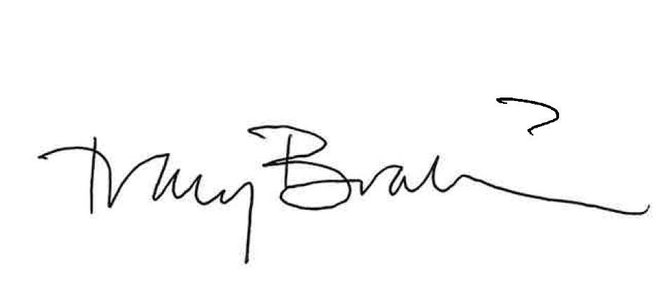

Tracy Brabin
Mayor of West Yorkshire

