West Yorkshire

Independent Custody Visiting Scheme Annual Report

2024-2025

**Contents**

Foreword 3

Overview 4

West Yorkshire 4

Introduction 5

Police Custody in West Yorkshire 6

Visits to Suites and Visits Overview 6

Our Volunteers 7

Governance 8

ICVA Quality Assurance Framework 8

Reporting 9

Issues raised by detained people to ICVs 9

Issues raised which cannot be resolved on site 10

Custody Visting Data 10

Visits per Suite 10

Time of Day 11

Days of the week 11

Detainees Seen 12

Detainees Not Seen 13

Code H 13

A National Picture 13

North-East Region 13

PACE Code H 13

Code H Volunteers 14

Independent Reviewer of Terrorism Legislation (IRTL) 14

Police Response 15

Custody Detention Scrutiny Panel 15

Future Plans 16

Useful Information and Contact Details 16

# Foreword

Welcome to the 2024/25 West Yorkshire Independent Custody Visiting Scheme Annual report.  Please do take time to read the report which outlines the wonderful work of our Independent Custody Visiting Volunteers over the last year.

**ICV Annual Report Foreword**

I am delighted to introduce the ICV Annual Report for 2024-2025.

This year’s findings reassure me that West Yorkshire Police are treating detained people with respect, dignity, and providing the appropriate care they deserve. I am honoured to serve for a second term as Deputy Mayor for Policing and Crime to support Mayor Brabin to continue working closely to make our region a safe, just and inclusive place to live, and ensure we have a policing service that works for everyone. I am committed to being a strong voice for all our communities across West Yorkshire and the Independent Custody Visiting Scheme is an integral part of this.

Our ICVs play a vital role in providing transparency and reassurance to our communities in what could otherwise be felt to be an exclusively closed environment, accessing our custody suites without prior notice 24/7 and having in-person discussions with detained people about their care and experience.

The scheme is an essential part of monitoring activity in custody and goes hand in hand with our newly established Custody and Detention Scrutiny Panel, which is a forum of independent scrutineers who come together on my behalf to review custody matters which involve a range of needs which may include mental health, vulnerable adults, use of force and young people.

I am grateful to our dedicated team of ICVs who give up their time and skills to help improve custody, and to West Yorkshire Police for their commitment and action in addressing the matters raised by ICVs.

**Alison Lowe OBE**

**Deputy Mayor for Policing and Crime**

**

# Overview

## West Yorkshire

* Five local authorities of Bradford, Calderdale, Kirklees, Leeds and Wakefield.
* Fourth largest police service area in England and Wales.
* Over 2.4m people with 973,000 households.
* Just under a third of the West Yorkshire population are under 24 and almost 17% are over 65.
* 90,500 businesses with a 1.3 million workforce.
* £74 billion economy.
* 7 universities, 115,000 students and 43,000 graduates each year.
* 22% of the population live in areas defined as the most deprived 10% in England.
* In West Yorkshire, 51,400 people were arrested and detained in police custody; on average, 140 people per day.
* Leeds and Bradford were the busiest suites by far, holding over 53% of the total number of detained people in West Yorkshire.
* 276 issues were raised by ICVs with the Policing and Crime Team, these are things which cannot be resolved immediately on site.

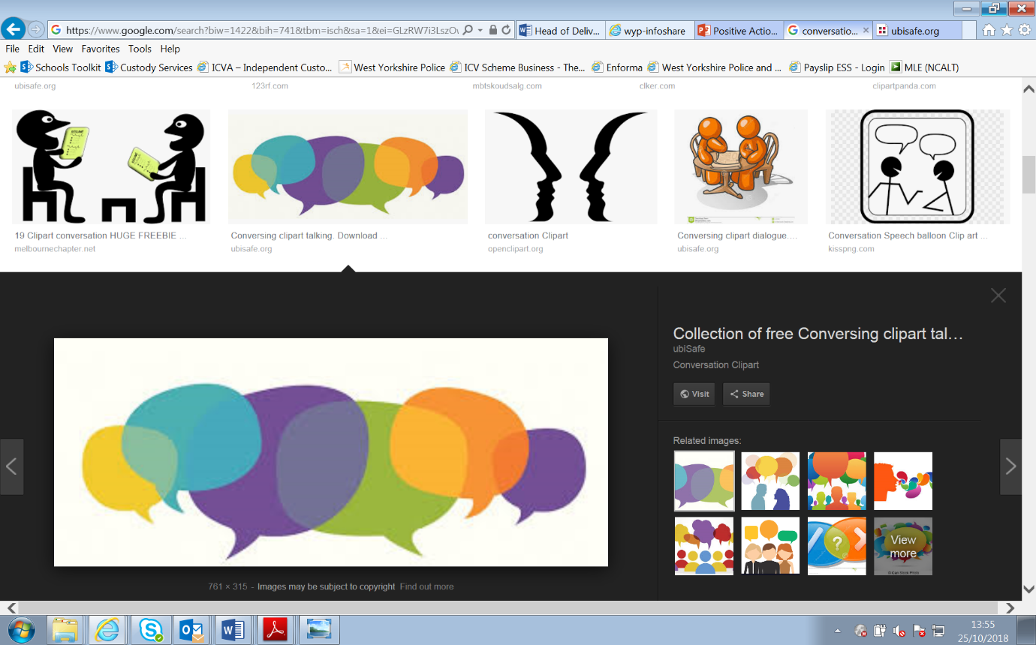

**In 2024/25**

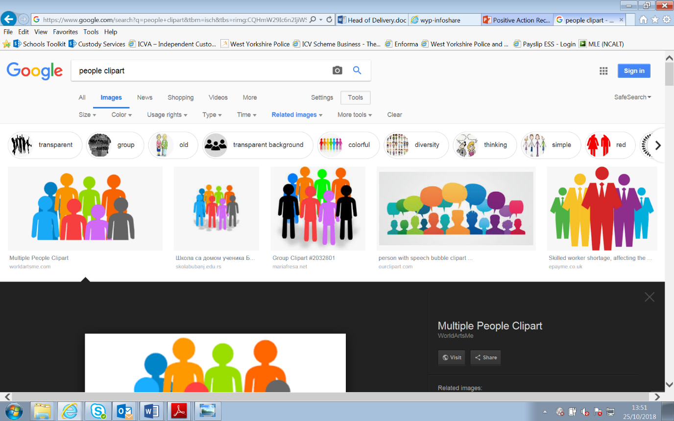

**291 visits**

**1434 detainees seen or spoken to**

**22 volunteers**

# Introduction

Administering an effective Independent Custody Visiting (ICV) scheme is a statutory responsibility of the Mayor as Police and Crime Commissioner. The Scheme is administered by the Policing and Crime Team on behalf of the Mayor. Robust systems must be in place to ensure that any issues with custody conditions or the people in them are highlighted and dealt with in the most appropriate way.

The ICV procedure is guided by the Home Office Code of Practice on independent custody visiting, which is issued in accordance with section 51 of the Police Reform Act 2002, as amended by section 117 of the Coroners and Justice Act 2009 and paragraph 299 of Schedule 16 to the Police Reform and Social Responsibility Act 2011.

Independent Custody Visitors (ICVs) are volunteer members of the local community who are unconnected to the police or the criminal justice system, whose independence therefore allows them to monitor the detention conditions and procedures in West Yorkshire to provide transparency and reassurance to the public that detention processes and policies are being adhered to. ICVs talk to detained people about their treatment whilst in custody.

**What does an ICV do?**

Many people arrive in custody without understanding their rights and entitlements and it can be frightening and stressful, especially if it will be their first experience in custody. Independent Custody Visitors ensure that detainees understand their rights and entitlements whilst in custody and check on the detainee’s general feeling and welfare and how they have been treated by custody staff. Visitors can also check around the cells, and some areas of the custody suite, for example the food preparation area. Visitors complete a report during each visit to record their findings.

# Police Custody in West Yorkshire

West Yorkshire Police operate five main custody suites with a total cell capacity of 151 cells.

|  |  |  |
| --- | --- | --- |
| **Suite** | **Number of Cells** | **Detainee Throughput 2024-2025** |
| Leeds District, Elland Road | 40 | 29,529 |
| Wakefield District, Havertop Lane | 35 | 18,215 |
| Bradford District, Trafalgar House | 34 | 27,625 |
| Calderdale District, Halifax | 21 | 11,746 |
| Kirklees District, Huddersfield | 21 | 16,475 |

There are two other suites located in Stainbeck (resilience suite) and Pudsey (standby suite). It is expected that the custody suite at Stainbeck will open and operate as an additional custody suite from mid-2025 and has a 34-cell capacity. Pudsey will become the resilience suite once Stainbeck opens.  Pudsey has 22 cells available. The North East region’s TACT suite is housed in West Yorkshire. The TACT suite is a specialised suite used to detain people arrested under the Terrorism Act 2000 (TACT).

Should a custody suite close or the resilience suite open this is communicated to the Policing and Crime team by Custody Services so that ICVs can be updated and arrange visits in accordance with standard protocols.

## Visits to Suites and Visits Overview

1,243 detainees were seen by ICVs in 2024-25 from a possible 3,556 who were offered. A detainee would not be offered if custody staff felt it likely that a visit would increase the level of risk for the detained person, custody colleagues and/or ICVs, for example if they were displaying particularly violent behaviours.

|  |  |  |  |  |
| --- | --- | --- | --- | --- |
| **Custody Suite** | **No. of ICV visits** | **No. of Detainees seen by ICVs** | **No. of detainees held at the time of the visit** | **Percentage of people seen, held at time of visit** |
| Bradford | 53 | 216 | 1134 | 19% |
| Calderdale | 54 | 172 | 484 | 36% |
| Kirklees | 49 | 190 | 631 | 30% |
| Leeds | 60 | 319 | 1690 | 19% |
| Wakefield | 56 | 226 | 897 | 25% |

**Figure 1 Shows the number of visits to each station and the total number of detainees seen on ICV visit against the total number of detainees held in custody at the time of the visit.**

# Our Volunteers

In March 2025, West Yorkshire had 21 volunteers.

West Yorkshire continues to promote inclusivity of all communities within its scheme, the demographics below outline the current proportion of volunteers based on age, gender and ethnicity:

|  |  |  |  |  |  |  |
| --- | --- | --- | --- | --- | --- | --- |
| **Gender** | **Male** | | **Female** | | | |
|  | 53% | | 47% | | | |
|  |  | |  | | | |
| **Age** | **18-30** | **31-40** | | | **41-50** | | | **51-60** | | **61-70** | | **71-80** | | **81+** | |
|  | 9% | 5% | | | 9% | | | 15% | | 38% | | 24% | | 0% | |
|  |  | |  | | | |  | |  | |  | |  | |  |
| **Ethnicity** | **White British** | | | **Asian or Asian British** | | **Black or Black British** | | |
|  | 76% | | | 14% | | 10% | | |

**Figure 2 Shows the demographics of ICVs in West Yorkshire at March 2025.**

As well as organised learning and development sessions, ICVs are encouraged to conduct visits with colleague ICVs they have not previously undertaken a visit with. Sharing experiences and differing communication techniques is essential in ensuring the continued development and growth of both the scheme and the volunteers.

**Support, Training and Development for ICVs**

ICVs are provided with training and support throughout the year, benefitting from specific sessions dedicated to team building, networking, information sharing, learning, and questions. Sessions were held in person in April 2024, October 2024, January 2025 and covered a range of topics including focus sessions on His Majesty's Inspectorate of Constabulary and Fire and Rescue Services (HMIFCRS) inspection reports and Appropriate Adults. ICVs influence the focus topics and can request topics which are of particular interest. West Yorkshire Police Custody colleagues attend every session and provide operational updates, subject matter expert advice and responses to questions.

# Governance

## ICVA Quality Assurance Framework

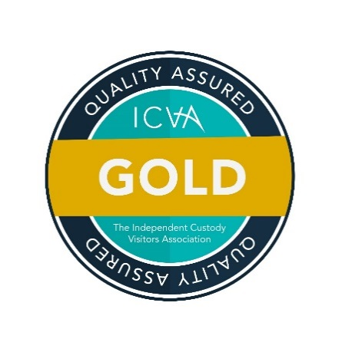The Independent Custody Visiting Association’s (ICVA) national Quality Assurance Framework (QAF) is designed to bring continuity between schemes and unify the way in which custody visiting is managed and delivered. Our assessment was undertaken by the Independent Custody Visitors’ Association, and the West Yorkshire scheme has continued to be recognised as operating at a ‘Gold’ standard, which is the level we applied for.

The Quality Assurance awards were introduced by ICVA to help schemes:

* Reflect on how they comply with the Code of Practice, the legislation that underpins custody visiting.
* Celebrate areas of strength.
* Promote custody visiting and the achievements schemes have made.
* Drive performance and increase sharing of good practice.

There were four graded levels of award:

* Code Complaint - Scheme meets statutory requirements and necessary volunteer standards.
* Silver – Scheme provides a good standard of custody visiting and volunteer management.
* Gold – Scheme provides an excellent standard of custody visiting and volunteer management.
* Platinum – Scheme provided an outstanding standard of custody visiting and volunteer management.

# Reporting

ICVs complete a report for each visit which records their findings. Their report can include anything the ICVs feel is of relevance or important, and usually includes detail on requests, or comments from detainees on issues that can be addressed on site by custody staff, such as an update, a phone call, or a drink.

## Issues raised by detained people to ICVs

As part of their conversation with detainees, ICVs can receive requests from detainees. Whilst responding to requests is not a role of ICVs, ICVs can note down their questions and raise with custody staff for consideration. We record this information to monitor trends, which could be an indicator of an underlying matter which needs consideration. Medical attention covers a wide-ranging field of requests, from pain relief for a minor ailment, such as a headache, sourcing medication from home, or seeing to minor injuries such as cuts, aches and bruising.

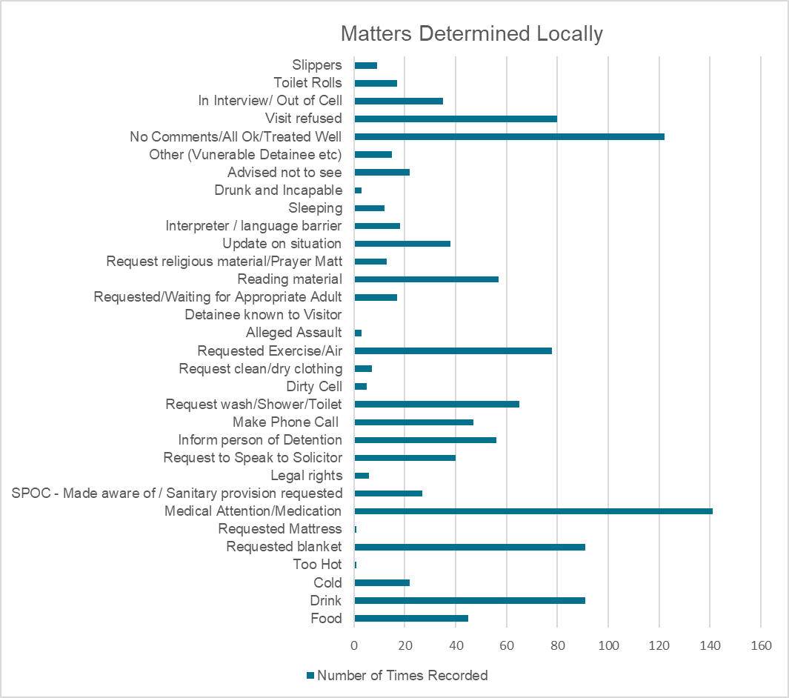

**Figure 3 shows the number of each request type made by detainees where a resolution could be considered/ provided by custody staff on site.**

## Issues raised which cannot be resolved on site

ICVs also record more significant issues for the Policing and Crime Team to facilitate a resolve at a force wide level with Custody Services. The responses from Custody Services are logged and monitored for themes and fed back to ICVs. 276 issues were reported to the Policing and Crime Team in 2024-25 that the suite could not resolve on site. These issues included but are not limited to resourcing, physical equipment, cleanliness and food supplied. All issues reported back to the Policing and Crime Team are followed up with Custody Services and a full response is shared with the ICVs.

# Custody Visting Data

In West Yorkshire, it is expected that as a collective ICVs will conduct one visit per suite, per week; 260 visits per year. Over the year, 291 visits were conducted, which is slightly up on last year’s visits. Of these visits 207 were rostered.

*Leeds was the most visited custody suite by ICVs, with 60 total visits, closely followed by Wakefield (56), Halifax (54), Bradford (53), then Huddersfield (49), plus 8 visits to other suites.*

*On average, people detained in West Yorkshire spent 11 hours and 24 minutes in custody.*

*Leeds was the busiest suite with 14,844 detainees held during 2024/25.*

Custody suites are obliged to allow ICVs access to custody suite as soon as practicable after they arrive. The average wait time for ICVs gaining access to custody was in just under 5 minutes and is comfortably within the service level agreement of entry within 10 minutes.

## Visits per Suite

The chart below shows the total number of visits in each custody suite. ICVs visited each suite proportionately achieving a consistent and co-ordinated approach.

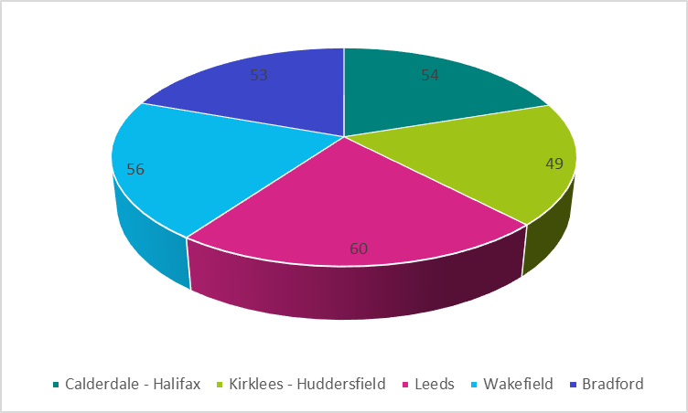

**Figure 4 shows the number of visits to custody suites.**

## Time of Day

ICVs are able to visit custody 24 hours a day, 7 days a week, 365 days of the year and are encouraged to visit outside of usual sociable hours i.e. before 08:00 and after 20:00. During 2024-25, 25 visits took place before 08:00 or after 20:00.

Most visits were undertaken between 08:01 and 12:00 with 132 visits taking place in these hours. 69 took place between 12:01 and 16:00, and 67 took place between 16:00 and 20:00. The time of day that visits are undertaken is dependent on the available hours of our volunteer ICVs, who must carry out their visits in pairs around personal and professional commitments.

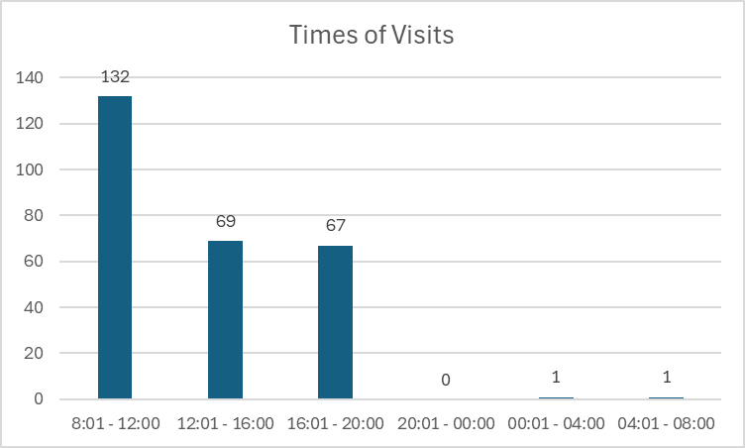

**Figure 5 shows the number of visits carried out against the time of day.**

## Days of the week

Visits were made over an equal spread during the week, visits on a Monday were most frequent with 58 visits, and the least with 31 visits taking place, was Wednesday, which is a change from last year, when Tuesday had the least number of visits.

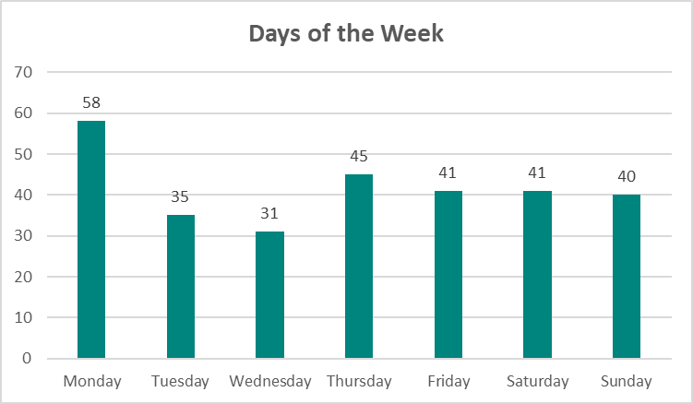

**Figure 6 shows the number of visits carried out against the day of the week.**

## Detainees Seen

ICVs continue to prioritise visits to women, children and vulnerable adults. A child is classed as anyone who is under the age of 18.

ICVs are informed which detainees they are unable to visit due to safety, i.e. if a detained person is presenting violent behaviours, intoxicated etc. The below graph shows the percentage of detainees visited from the number of detainees in custody at the time of the visit.

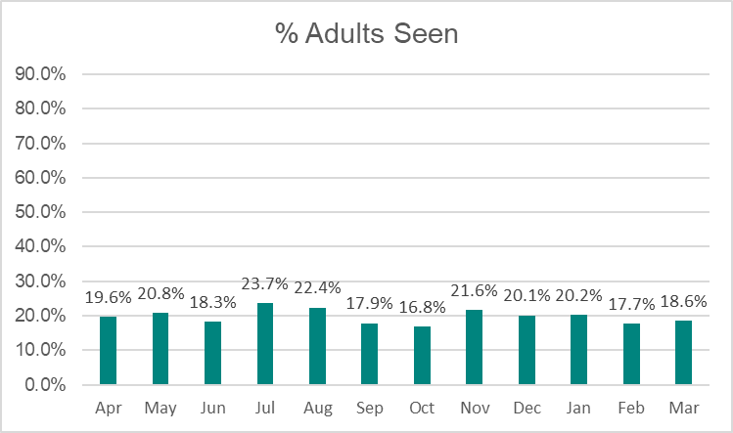

**Figure 7 shows the percentage of adult detainees seen from the total number of detainees in custody at the start of a visit.**

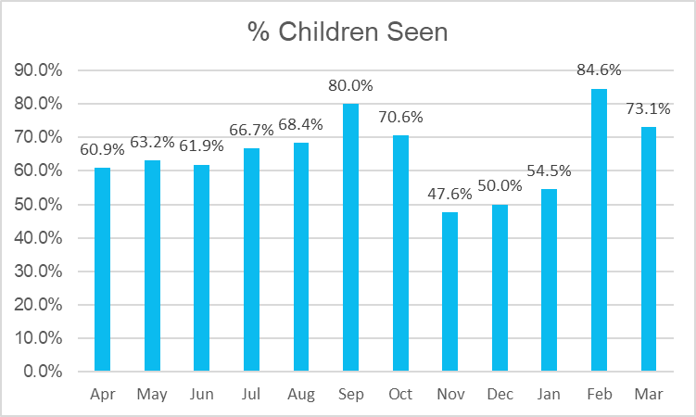

**Figure 7 shows the percentage of child detainees seen from the total number of detainees in custody at the start of a visit.**

## Detainees Not Seen

Detainees are not obliged to accept a visit from ICVs, although 86% of detainees who were offered a visit, accepted one. ICVs are encouraged to undertake ‘self-introductions’ rather than being introduced by a uniformed custody colleague to amplify the ICV’s independent position. ICVs receive specific training on communication and personal skills, to support them in being approachable and to manage their unconscious bias in their communication and body language.

# Code H

## A National Picture

The threat to the UK from terrorism remains substantial, meaning an attack is likely.

The Counter Terrorism Policing network is currently working on a record number of more than 800 investigations. These investigations, the majority in partnership with MI5, focus on a range of activities, including fundraising, radicalising and preparing acts of terrorism.

Demand continues to grow, as does the complexity of what the police are dealing with.

The police are seeing increasingly fragmented ideologies, a continuing shift towards self-initiated terrorism and hateful online ideologies filtering into the lives of young people.

Working closely with MI5 and other partners the police prioritise their resources against those cases that pose the most risk to the public.

Since March 2017, Counter Terrorism Policing and UK Intelligence Services have stopped 43 attacks.

In the 12 months to 31 December 2024 there were 248 Counter Terrorism related arrests. 61% of the arrests were related to suspected Islamist Terrorism. 30% of the arrests were related to suspected Extreme Right-Wing Terrorism (ERWT). 9% of arrests can be categorised as other or unclassified. 19% of those arrested were female. Over the 12 months to 30 June 2023, 39 of the 248 arrests were children under the age of 18.

## North-East Region

## PACE Code H

West Yorkshire houses the North East Region’s Terrorism Act (TACT) facility, which is opened on a reactive, need basis and is used to detain people who are arrested under PACE Code H. Persons detained under PACE Code H are persons who have been arrested on suspicion of being, or have been concerned in the commission, preparation or instigation of acts of terrorism or have been arrested for statutory offences as detailed in the Terrorism Act. Persons held under PACE Code H can be detained for up to 14 days, significantly longer than those arrested under PACE Code C of whom can be detained for up to 96 hours without charge; and the rights, entitlements and suite change accordingly to reflect the differing needs.

Each detained person held at the North East Region’s TACT facility was spoken to by an Independent Custody Visitor within 24 hours. Issues raised by detainees with ICVs and locally resolved on site by custody staff included requests for reading material, a change of clothes and medical attention.

The Code H ICV Visit Protocol accommodates 24/7 contact between Code H ICVs and the custody suite during evenings and states the need to arrange an ICV visit daily, where available.

**PACE Code I**

PACE code I was recently introduced to govern the detention, treatment and questioning by police of persons in detention under section 27 of, and Schedule 6 to, the National Security Act 2023. As of now, West Yorkshire has not had any persons detained under PACE Code I.

## Code H Volunteers

ICVs must hold at least 18 months service as a Code C ICV, before they are able to train to undertake Code H Visits. They need to undergo further vetting and receive additional specialist training. Training for Code H ICVs includes input from an expert West Yorkshire Police Counter Terrorism Unit (CTU) trainer, the ICV Scheme Manager and includes a physical tour of the dedicated suite.

## Independent Reviewer of Terrorism Legislation (IRTL)

The Independent Reviewer’s role is to inform the public and political debate on anti-terrorism law in the United Kingdom. This is done via regular reports for the Home Secretary or Treasury and laid before Parliament, in evidence to parliamentary committees, in articles and speeches, in media interviews and debates and online platforms

The role has complete independence from government, and comes with access based on a very high degree of clearance to secret and sensitive national security information and personnel. In performing the role, the IRTL speaks to the widest possible range of people with experience of how anti-terrorism law operates, including the police, those who are stopped, arrested and detained and ICVs. All ICV visit report forms with those who are arrested under Pace Code H and/or PACE Code I are sent to the IRTL for review by the Policing and Crime Team.

In May 2019, Jonathan Hall KC had been appointed by the Home Secretary as Independent Reviewer of Terrorism Legislation, and re-appointed in March 2022, with a further extension (until November 2026) in November 2024. In addition, in February 2024 Jonathan was appointed as the first Independent Reviewer of State Threats Legislation under the National Security Act 2023, which requires him to review the new offences and powers created by the 2023 Act, together with ports powers used in connection with hostile state activity under Schedule 3 to the Counter-Terrorism and Border Security Act 2019.



Jonathan’s annual terrorism reports can be found on the [IRTL website](https://terrorismlegislationreviewer.independent.gov.uk/category/reports/).

**Jonathan Hall KC**

# Police Response

Positive working relationships between ICVs and custody staff are integral to the success of the scheme. Ongoing work is undertaken and continually reviewed by Custody Services, Training and Development and the Policing and Crime Team to ensure that both parties understand the roles and responsibilities.

We regularly receive feedback that custody staff were accommodating and helpful, which is a reflection that the continued training has a positive impact.

This good working relationship and continuous engagement allows our ICVs to:

***Know they are valuable and make a difference.***

***Provide support and training to peers.***

***Feel empowered to drive change***

***Ask questions and provide challenge and reassurance.***

***Enjoy their role.***

# Custody Detention Scrutiny Panel

This year, the Mayor and DMPC established a West Yorkshire Custody Detention Scrutiny Panel (CDSP), which is a group made up of local people selected from across the policing area, to represent local communities in conversations with police officers and staff who are actively involved in the detention and custody environments across our county. Over recent years, national independent reviews such as the ‘Lammy Review,’ and the ‘Angiolini Review’ have identified issues of disparity and inequality in the Criminal Justice System across the UK which has led to a trust deficit between communities and the police up and down the country. The West Yorkshire CDSP is given unprecedented access to police information in order to objectively and independently review matters of disproportionality and police/detainee behaviour with an ambition to reassure the public that concerns are taken seriously and dealt with transparently. The areas of focus are determined by the independent panel members and currently include use of force, mental health, children and strip searches. Independent Custody Visitors form part of the CDSP membership. If you are interested in joining the West Yorkshire Custody Detention Scrutiny Panel, or would like more information, please email: [policingandcrime@westyorks-ca.gov.uk](mailto:policingandcrime@westyorks-ca.gov.uk)

# Future Plans

One of the main focusses for West Yorkshire in 2025-26 will be to recruit additional ICVs. The recruitment drive will again have a focus on inclusivity from all communities to strive towards having a truly representative team of volunteers. We will also look for further ICVs to train and become Code H/ Code I nominated ICVs.

# Useful Information and Contact Details

[policingandcrime@westyorks-ca.gov.uk](mailto:policingandcrime@westyorks-ca.gov.uk)

**Policing and Crime Team**

**West Yorkshire Combined Authority**

**Wellington House**

**40-50 Wellington Street**

**Leeds**

**West Yorkshire**

**LS1 2DE**

**Tel: 0113 3481653**

(please leave a message and a member of the team will call you back)

**Interested in Joining?**

If you would like more information on becoming an Independent Custody Visitor in West Yorkshire then please email: [policingandcrime@westyorks-ca.gov.uk](mailto:policingandcrime@westyorks-ca.gov.uk)

**Policing and Crime Team**

For more information regarding the work of the Policing and Crime Team for West Yorkshire please visit: [Policing and Crime - West Yorkshire Combined Authority (westyorks-ca.gov.uk)](https://www.westyorks-ca.gov.uk/policing-and-crime/) and Custody Visiting [Custody Visiting - West Yorkshire Combined Authority (westyorks-ca.gov.uk)](https://www.westyorks-ca.gov.uk/policing-and-crime/custody-visiting/)

**West Yorkshire Mayor**

[West Yorkshire Combined Authority](https://www.westyorks-ca.gov.uk/a-mayoral-combined-authority/)

**West Yorkshire Deputy Mayor for Policing and Crime**

[West Yorkshire Combined Authority](https://www.westyorks-ca.gov.uk/policing-and-crime/about-the-deputy-mayor-for-policing-and-crime/)

## Find out more westyorks-ca.gov.uk

**West Yorkshire Combined Authority**

Wellington House  
40-50 Wellington Street  
Leeds  
LS1 2DE

All information correct at time of writing

**Independent Custody Visiting Association**

If you would like more information on the role of the national Independent Custody Visiting Association (ICVA) please visit: <https://icva.org.uk/>